**WinAPI in ASM**

WINAPI IN ASSEMBLY INTRODUCTION 2

DISPLAYING A MESSAGEBOX 18

CONSOLE INPUT 25

CHECKING FOR ERRORS 26

SINGLE CHARACTER INPUT 27

CONSOLE OUTPUT 34

FILE HANDLING 40

WRITEFILE AND SETFILEPOINTER 45

CONSOLE WINDOW MANIPULATION 52

SETTING TEXT COLOR 60

TIME, WINAPI AND ASSEMBLY 61

CALLING 64-BIT WINAPI FUNCTION IN MASM 69

DYNAMIC MEMORY 84

x86 MEMORY MANAGEMENT 96

WINAPI IN ASSEMBLY INTRODUCTION

When a Windows application starts up, it can launch in one of two ways:  
either as a **console application** or as a **graphical (windowed) application**.

In our project files, we tell the linker that we want a console-based program by using this option with the LINK command:

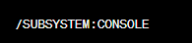

A console program looks a lot like the old MS-DOS window—but with some modern upgrades we’ll get into soon.

Under the hood, the console includes:

**One input buffer**, which stores input records. These records describe things like:

* Keyboard input
* Mouse clicks
* User actions such as resizing the console window

**One or more screen buffers**, which are two-dimensional arrays holding:

* Character data
* Color and attribute information

These screen buffers control how text actually appears inside the console window.



Reference Material (a.k.a. where the real answers live)

* I’ve put Win32 API reference info in **my own GitHub repository**.  
  If you don’t see it, just email me and I’ll send you a ZIP file.
* **Charles Petzold’s book** is another classic reference.  
  Fair warning: it’s old-school—huge, technical, no colors, no hand-holding.  
  If you enjoy reading 1000-page technical manuals without falling asleep, it’s for you.  
  If you want the physical book… well, more power to you—go buy it 😄

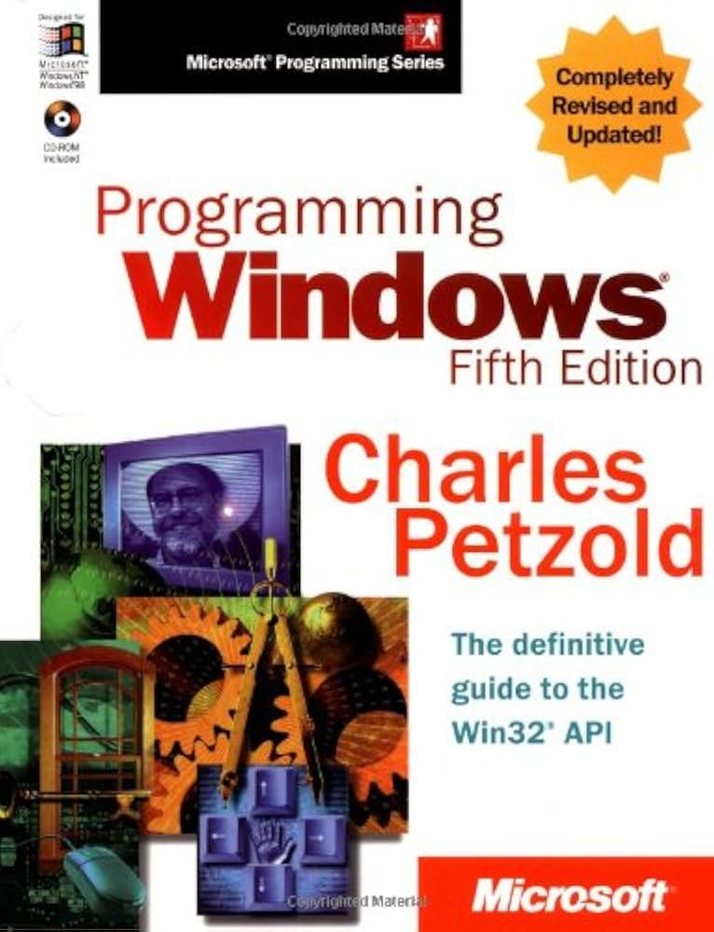

Key Takeaways from This Section

* This section introduces **a small subset of Win32 API functions**, using simple examples.  
  It’s meant as a starting point, not a complete reference.
* For full documentation, the **Microsoft MSDN website** is the authoritative source.  
  When searching, make sure to filter for **“Platform SDK.”**
* The sample programs include lists of function names found in:
  + kernel32.lib
  + user32.lib  
    These are provided mainly for reference.
* Win32 API functions often rely on **named constants**, such as:

In Microsoft’s MSDN Library documentation, the trailing **“A”** or **“W”** is typically omitted from function names.

In the program include files provided with this book, functions such as WriteConsoleA are redefined as follows:

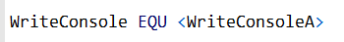

This definition allows you to call WriteConsole using a generic function name, without explicitly specifying the character set.

There are two levels of console access, each balancing ease of use and control:

High-Level Console Functions

* Read a stream of characters from the console’s input buffer.
* Write character data to the console’s screen buffer.
* Support input and output redirection to and from text files.
* Simpler to use, but offer less control over console behavior.

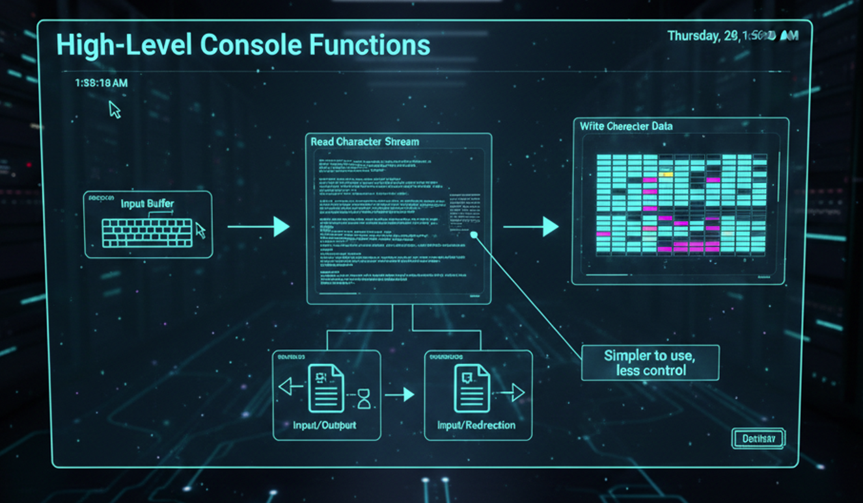

Low-Level Console Functions

* Provide detailed information about keyboard and mouse events.
* Capture user interactions with the console window (such as dragging and resizing).
* Allow precise control over the console window’s size, position, and text colors.
* More complex, but offer full control over console operations.

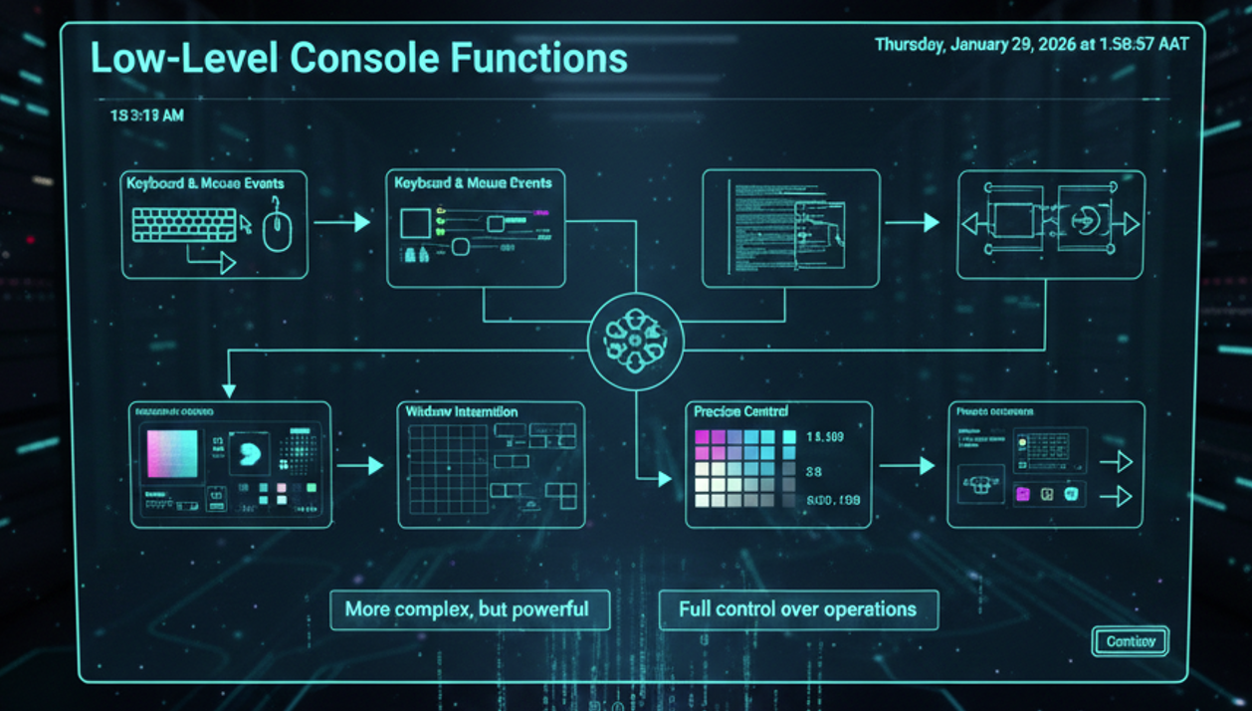

Windows Data Types

MASM provides its own versions of the standard MS-Windows data types. The mappings are pretty straightforward, once you see how they line up.

**MASM ↔ Windows Type Mappings**

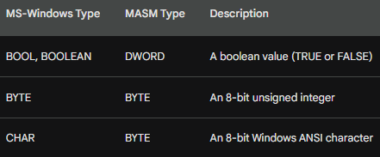

In other words, these MASM types are effectively equivalent to their Windows counterparts:

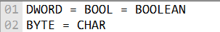

So, if you see a Windows function expecting a BOOL, using a DWORD in MASM is perfectly correct.

A Note About HANDLEs (Important!)

One thing that often surprises people:  
the Windows HANDLE type is **also just a DWORD**.

That means a single HANDLE variable can store a reference to many different kinds of objects, such as:

* A window
* A file
* A memory region
* Other system objects

The meaning of the handle depends entirely on **which API function returned it**—not on the data type itself.

Here is an example of how to declare and use a HANDLE variable in MASM:

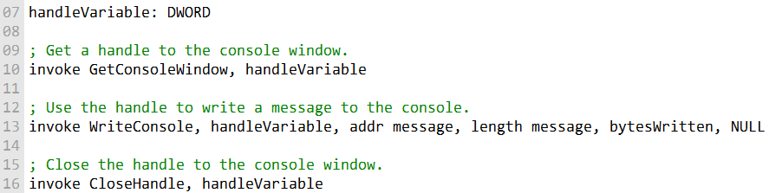

The **SmallWin.inc** include file contains constant definitions, text equates, and function prototypes used in Win32 API programming.

It is automatically included in programs through **Irvine32.inc**.

The file defines several Win32 data types, including the **HANDLE** type.

Below are examples demonstrating how to use the **SmallWin.inc** include file:

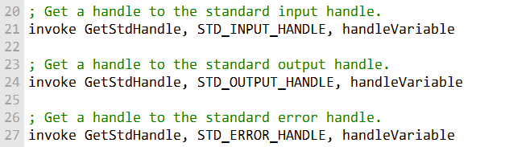

SmallWin.inc and Win32 Data Types (MASM-Friendly Overview)

The SmallWin.inc include file exists to make **Win32 API programming in MASM less painful**.  
It defines common Windows data types, structures, constants, and function prototypes so you don’t have to reinvent the wheel every time.

It’s automatically included when you use Irvine32.inc, so in most MASM projects, you already have access to it.

I. Common Windows Data Types

Here’s what the most common Win32 data types actually mean, without the legalese:

* **BOOL / BOOLEAN**  
  A simple true-or-false value.
* **BYTE**  
  An 8-bit unsigned integer (0–255).
* **CHAR**  
  An 8-bit Windows ANSI character.  
  This is what older (non-Unicode) Windows programs use for text. The exact character set depends on language and region.
* **DWORD**  
  A 32-bit unsigned integer (0–4,294,967,295).
* **WORD**  
  A 16-bit unsigned integer (0–65,535).
* **INT / LONG**  
  A 32-bit signed integer  
  (−2,147,483,648 to +2,147,483,647).  
  INT and LONG are the same size in Win32.
* **UINT**  
  A 32-bit unsigned integer, functionally the same as DWORD.

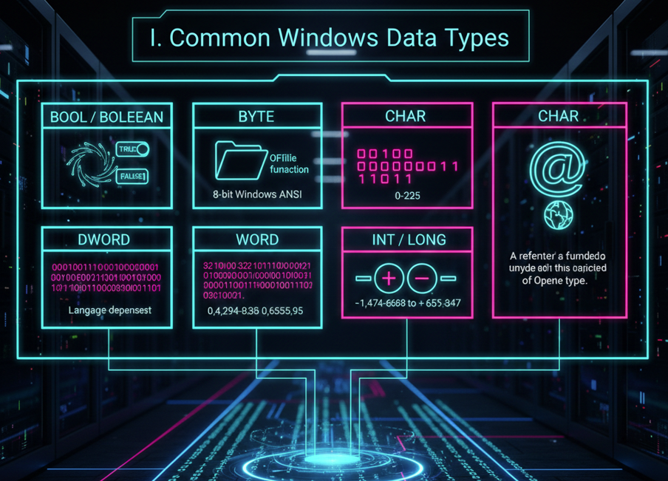

II. Handles and Pointer Types

* **HANDLE**  
  A reference to a Windows object (window, file, memory region, etc.).  
  Internally, it’s just a 32-bit value, but *what it refers to* depends on how you got it.
* **HFILE**  
  A handle returned by the OpenFile function.
* **LPVOID**  
  A pointer to *anything* (unspecified type).
* **LPCVOID**  
  A pointer to constant data of any type.

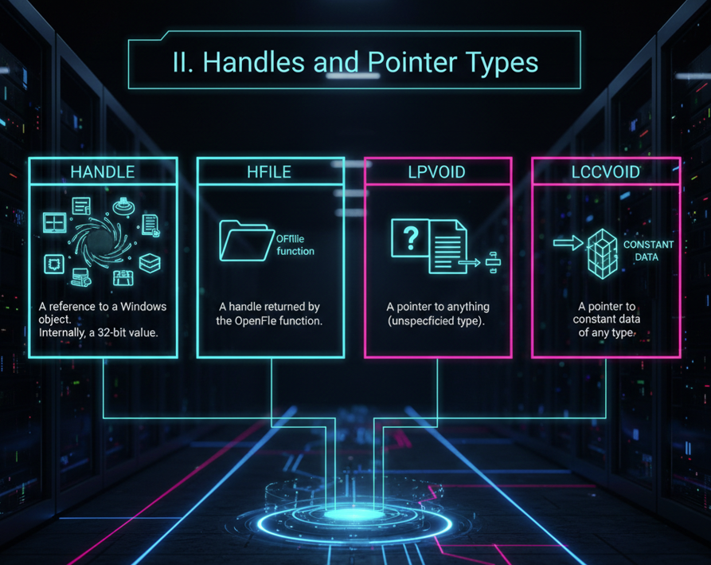

III. String and Text Pointer Types

These show up everywhere in the Windows API:

**LPSTR** - Pointer to a null-terminated ANSI string.

**LPCSTR -** Pointer to a constant null-terminated ANSI string.

**LPTSTR -** Pointer to a character string that works with both ANSI and Unicode builds.

**LPCTSTR** - Pointer to a constant string that’s portable across ANSI, Unicode, and double-byte character sets (used in languages like Chinese and Japanese).

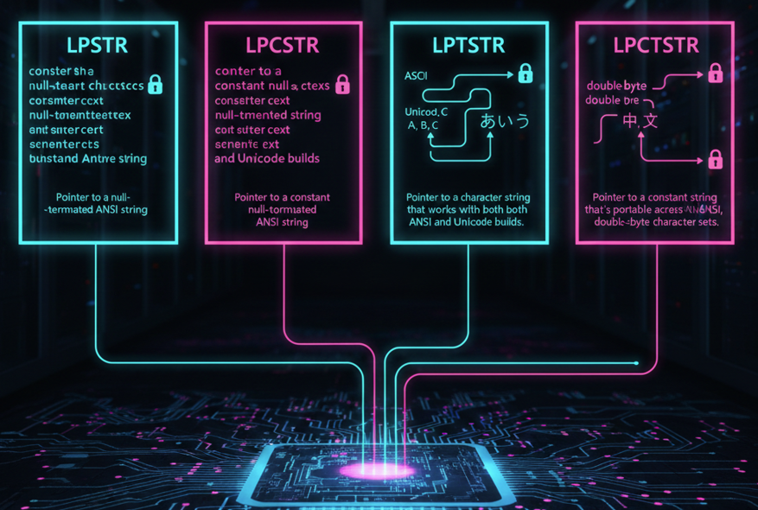

IV. Message and Callback Types

* **WPARAM**  
  A 32-bit value passed to a window procedure.  
  Usually contains message-related info.
* **LPARAM**  
  Another message parameter.  
  Often used to store pointers to structures or other data.
* **LRESULT**  
  A 32-bit value returned by a window procedure or callback.
* **WNDPROC**  
  A pointer to a window procedure function (the function that processes window messages).

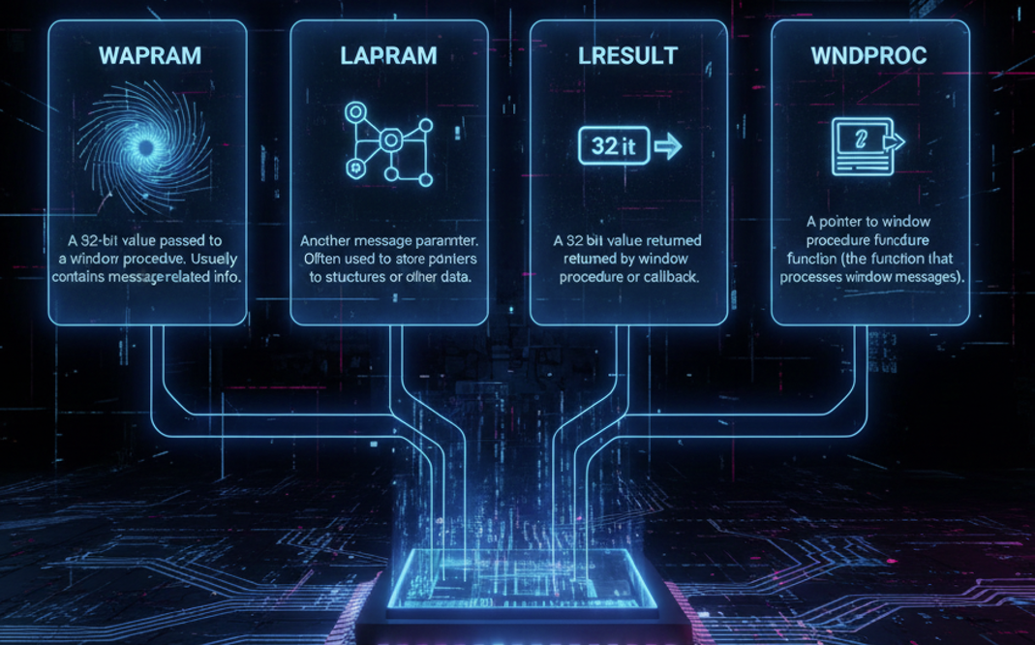

Special Structures

I. COORD Structure

Used to store a position in the console window.

* X – horizontal coordinate
* Y – vertical coordinate

Both values are WORDs.

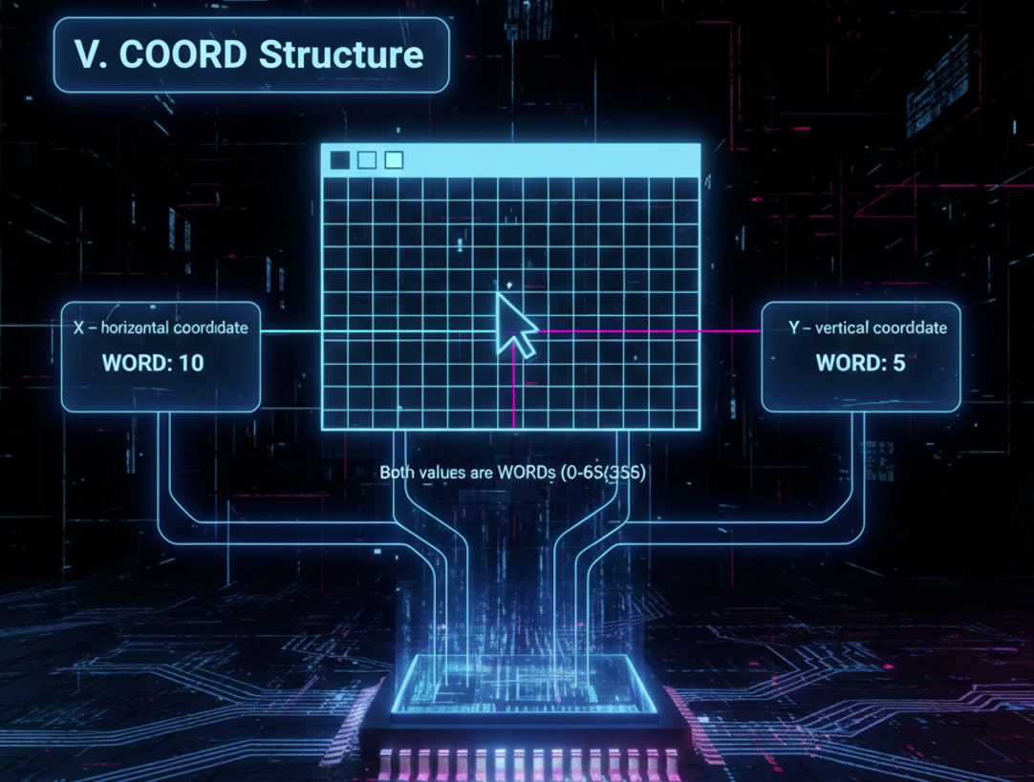

II. SYSTEMTIME Structure

Stores detailed date and time information:

* wYear – year
* wMonth – month
* wDayOfWeek – day of the week
* wDay – day of the month
* wHour – hour
* wMinute – minute
* wSecond – second
* wMilliseconds – milliseconds

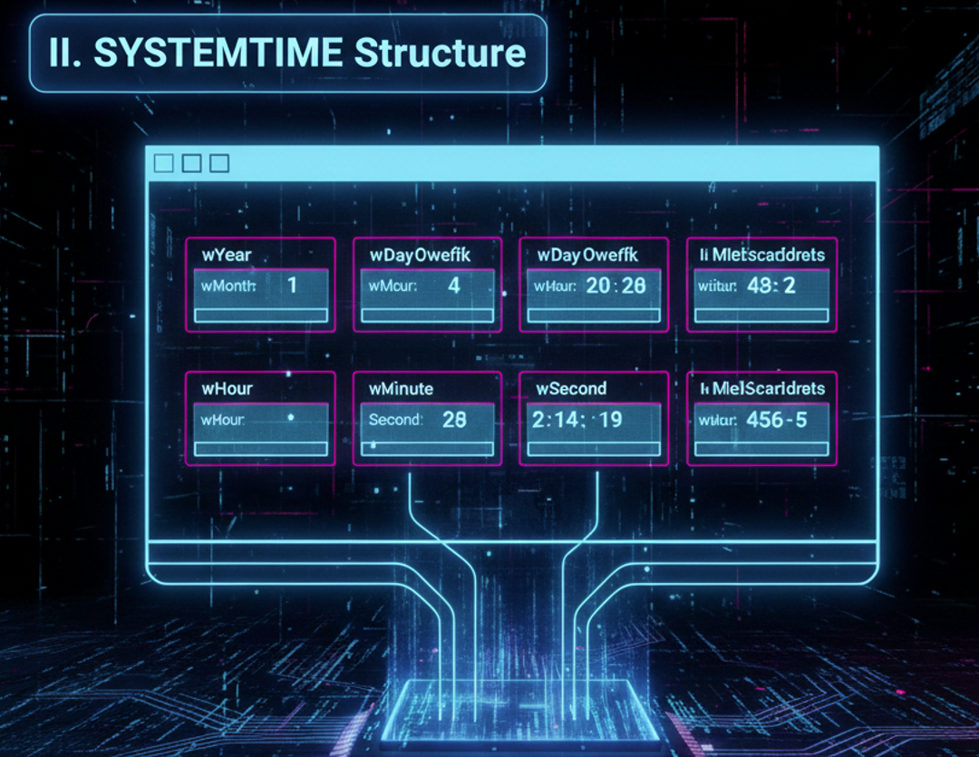

Console Handles (The Backbone of Console I/O)

Console handles are **32-bit values** that identify console devices.  
Win32 console functions use these handles to perform input and output.

**The Three Standard Console Handles**

* **STD_INPUT_HANDLE** – keyboard input
* **STD_OUTPUT_HANDLE** – console display output
* **STD_ERROR_HANDLE** – error message output

You retrieve these using: **GetStdHandle**

Once you have a handle, you can use it to read input, write output, or control the console’s behavior.

Common Console I/O Functions

I. Input and Output

* **ReadConsole** – reads keyboard input
* **ReadConsoleInput** – reads keyboard, mouse, and other events
* **WriteConsole** – writes text to the console (most commonly used)

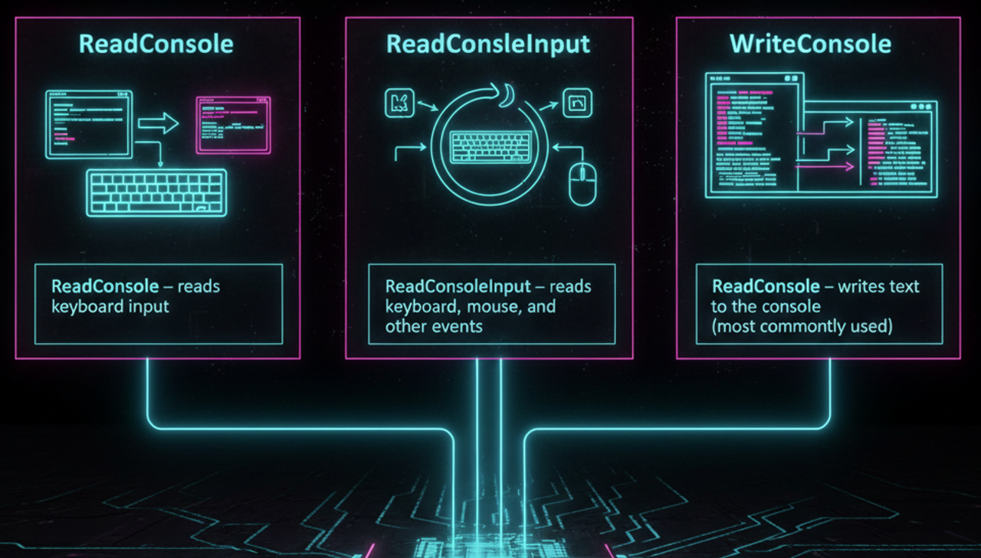

II. Screen Buffer Access

* **CreateConsoleScreenBuffer** – creates a new screen buffer
* **SetConsoleActiveScreenBuffer** – switches which buffer is visible
* **ReadConsoleOutput** – reads characters and colors from the screen
* **WriteConsoleOutput** – writes characters and colors to the screen

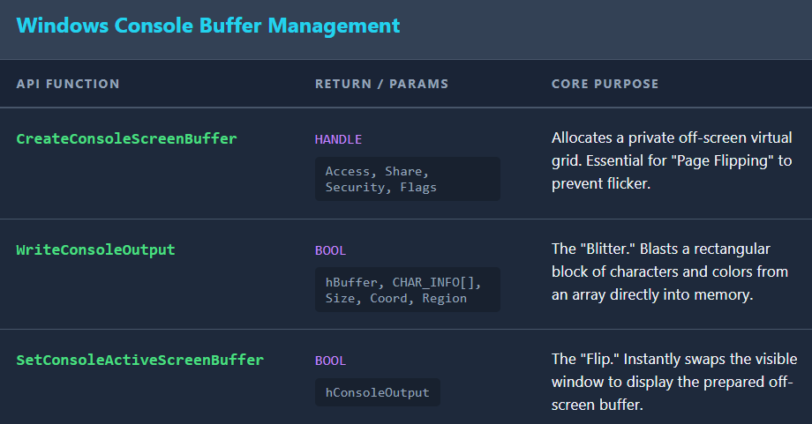

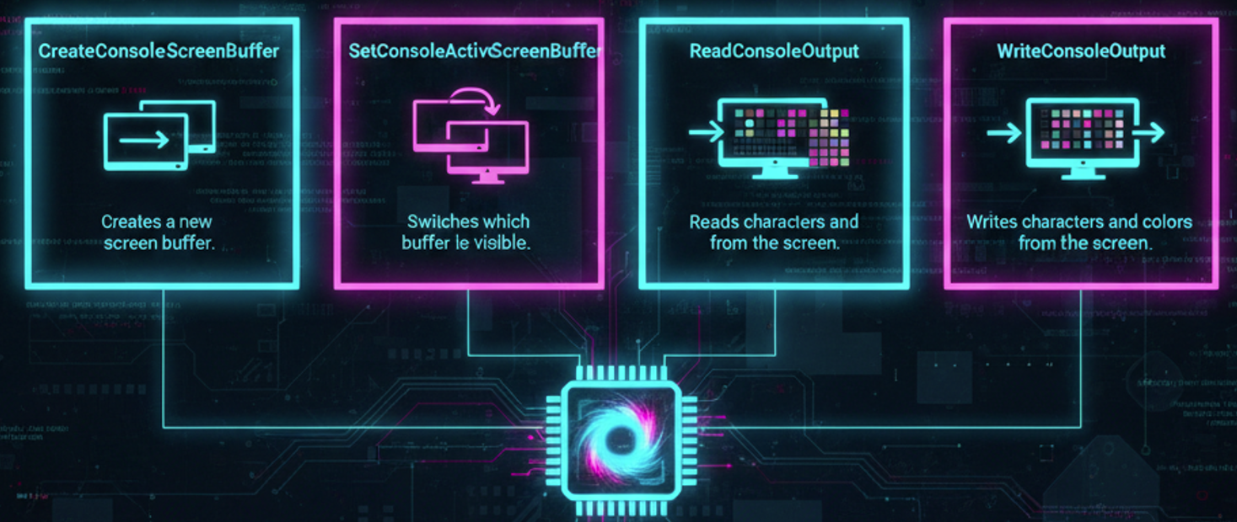

III. Console Appearance and Behavior

* **SetConsoleTextAttribute** – changes text and background colors
* **FillConsoleOutputCharacter** – fills an area with a character
* **FillConsoleOutputAttribute** – fills an area with color attributes
* **SetConsoleCursorPosition** – moves the cursor
* **SetConsoleCursorInfo** – controls cursor size and visibility
* **SetConsoleWindowInfo** – resizes or moves the console window
* **SetConsoleTitle** – sets the console window title

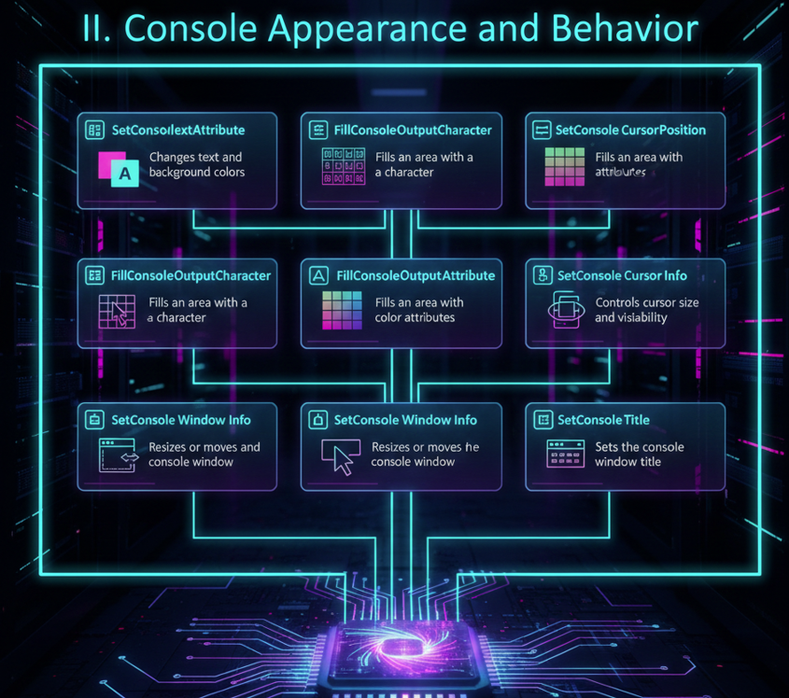

IV. Console Modes and Code Pages

* **GetConsoleMode / SetConsoleMode** – control input/output behavior
* **GetConsoleCP / SetConsoleCP** – get or set input code page
* **GetConsoleOutputCP / SetConsoleOutputCP** – get or set output code page

These are especially important for international character support.

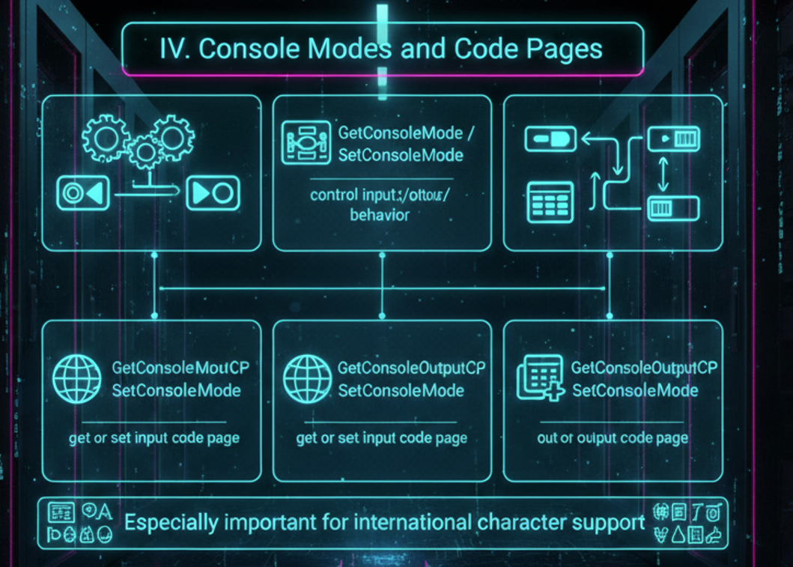

V. Console Management and Control

* **AllocConsole** – creates a new console
* **FreeConsole** – detaches from the console
* **FlushConsoleInputBuffer** – clears unread keyboard input
* **GetConsoleWindow** – retrieves the console’s window handle
* **GetConsoleTitle** – retrieves the current console title
* **GetLargestConsoleWindowSize** – maximum possible console size

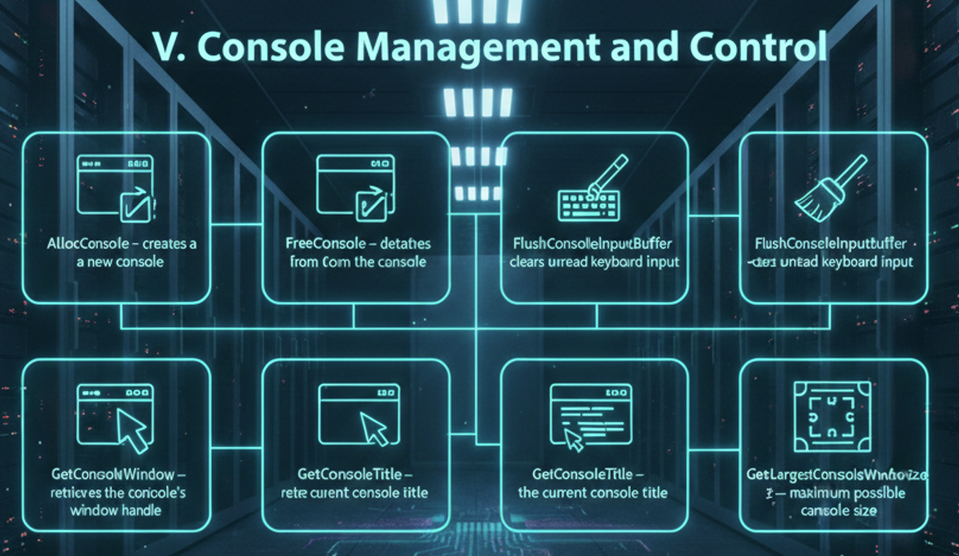

VI. Console Events and Signals

* **SetConsoleCtrlHandler** – registers a handler function
* **HandlerRoutine** – your custom handler function
* **GenerateConsoleCtrlEvent** – sends control signals (close, terminate, etc.)

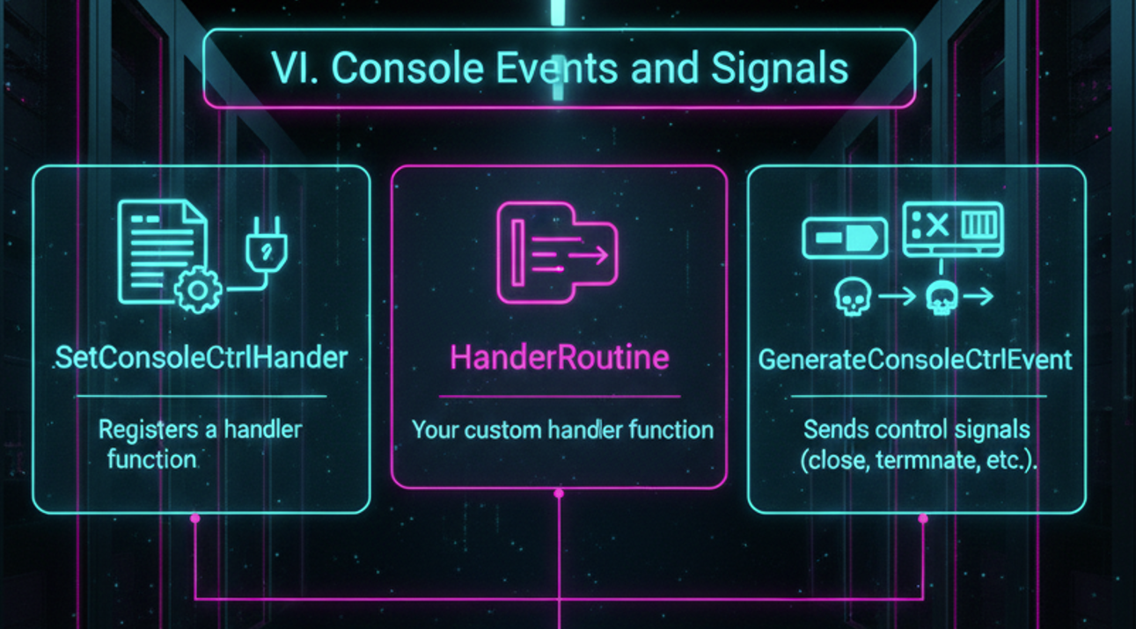

VII. Why This Matters

Console handles and Win32 console functions are **the core of console-based Windows programs**.  
Once you understand how handles, buffers, and modes fit together, you can:

* Build responsive console apps
* Control text layout and color
* Handle keyboard and mouse input
* Manage multiple screen buffers

In short: **this is where simple DOS-style programs turn into real Windows applications.**

DISPLAYING A MESSAGEBOX

In Win32 console applications, you can use the **MessageBoxA** function to display a message box to the user.

The MessageBoxA function requires **four parameters**:

**hWnd**

* A handle to the window that owns the message box.
* If this parameter is NULL, the message box is created as a top-level window.

**lpText**

* A pointer to the text displayed inside the message box.

**lpCaption**

* A pointer to the text displayed in the message box’s title bar.

**uType**

* A bit-mapped integer that specifies the type of message box.
* This parameter controls:
  + The buttons displayed (e.g., OK, Yes/No)
  + The icon displayed
  + The default selected button

The following table lists some of the possible values for the **uType** parameter:

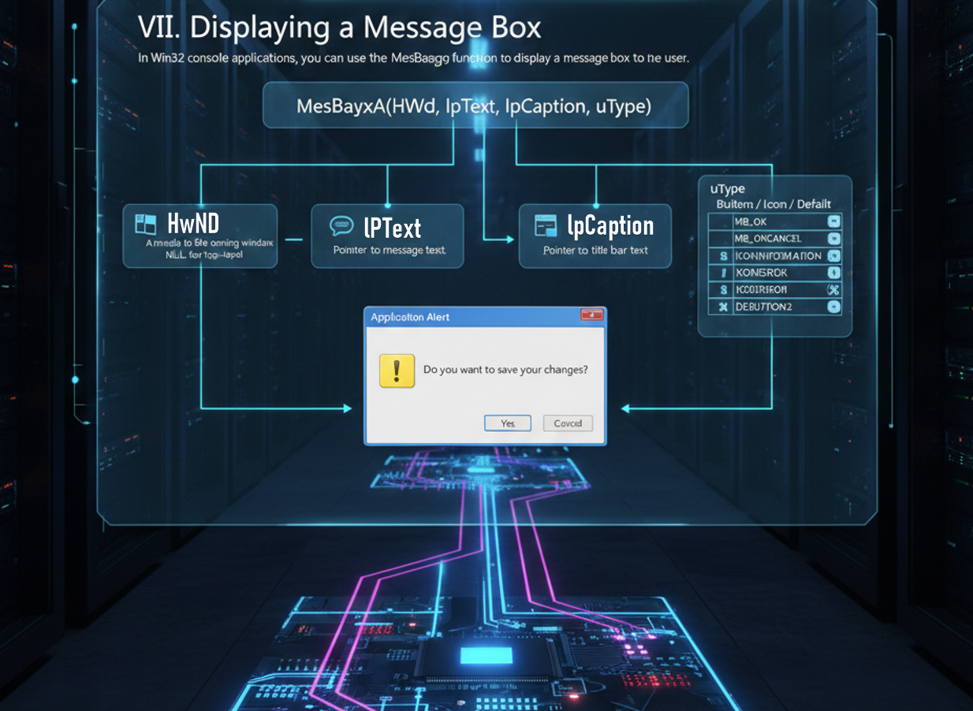

We learnt all this in the Windows API notes.

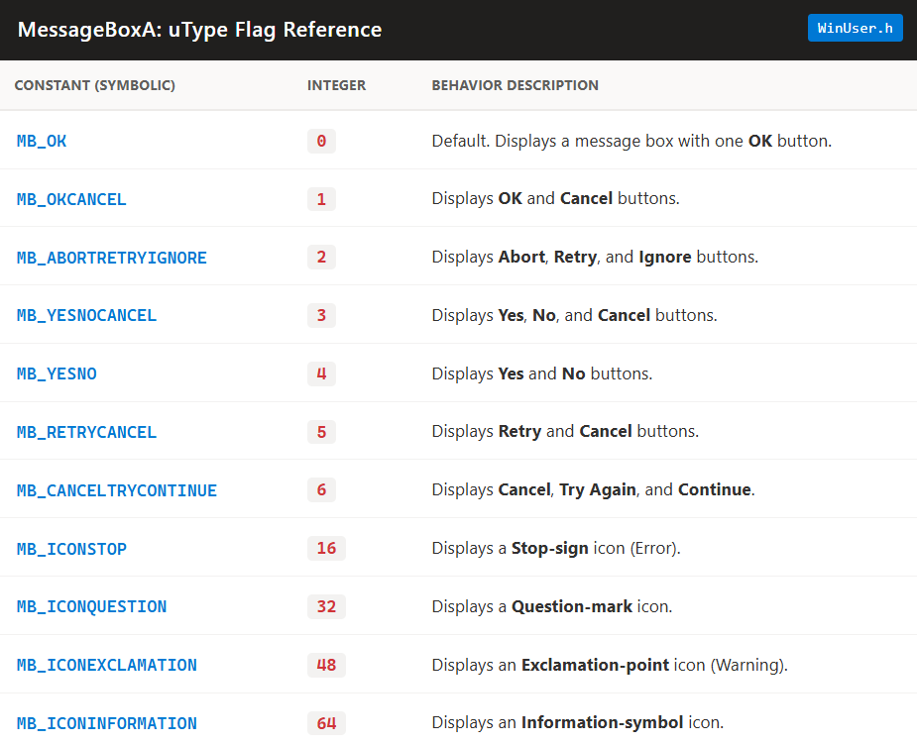

The **values in the table** are commonly used as **integer constants** for the **uType** parameter when creating message boxes.

The **uType** parameter determines the **type and behavior** of the message box.

In your program, you can use these constants like this:

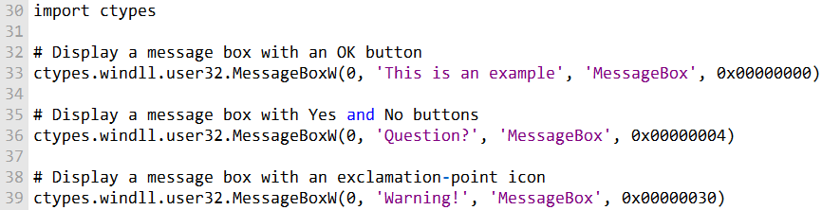

Or

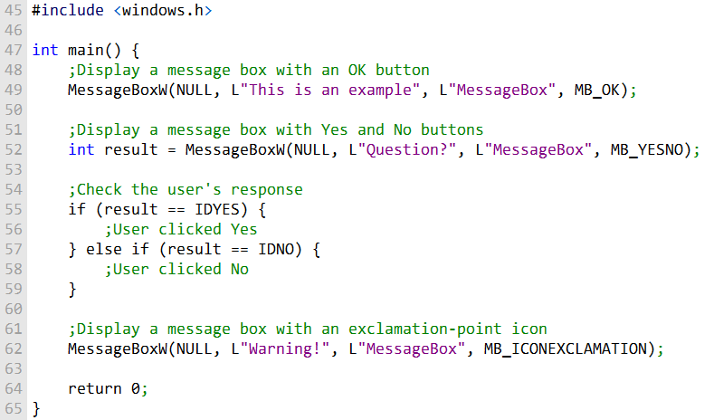

In this C program, different **message box types** are used, including:

* MB_OK – displays a single OK button
* MB_YESNO – displays Yes and No buttons
* MB_ICONEXCLAMATION – displays an exclamation icon

To specify the message box type, pass the corresponding **integer constant** as the **third parameter** to the MessageBoxW function.

The program can **check the user’s response** to the Yes and No buttons by examining the value returned by the function.

* For example, IDYES indicates the user clicked Yes.
* IDNO indicates the user clicked No.

Or

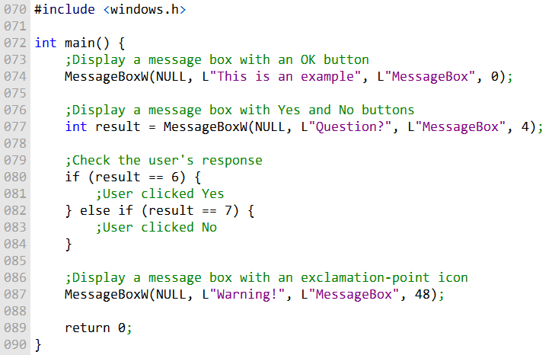

* In this code, **integer values** are used directly to specify message box types.
* Examples of integer values and their corresponding constants:
  + 0 → MB_OK (single OK button)
  + 4 → MB_YESNO (Yes and No buttons)
  + 48 → MB_ICONEXCLAMATION (exclamation icon)
* You can use these values to create message boxes with the **desired type and behavior** in your C program.

Demonstration Program

Program that demonstrates some capabilities of the MessageBoxA function.

The first function call displays a warning message:

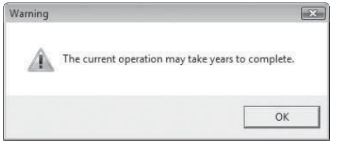

The second function call displays a question icon and Yes/No buttons.

If the user selects the Yes button, the program could use the return value to select a course of action:

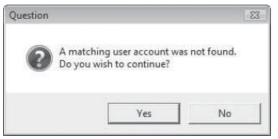

The third function call displays an information icon with three buttons:

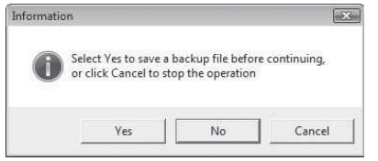

The fourth function call displays a stop icon with an OK button:

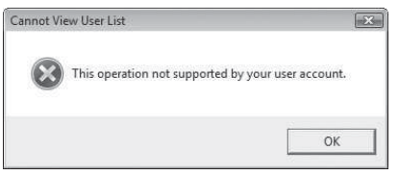

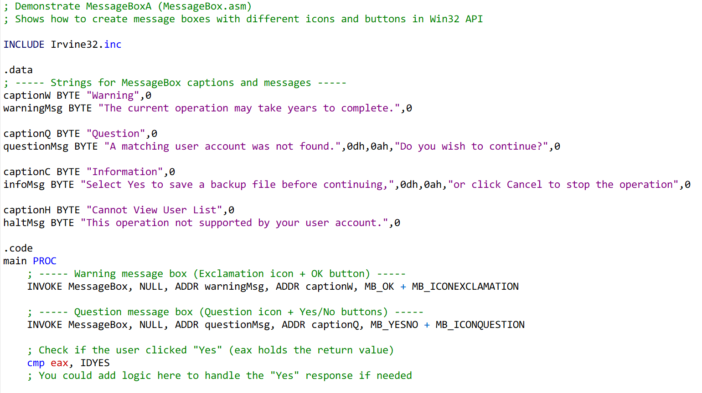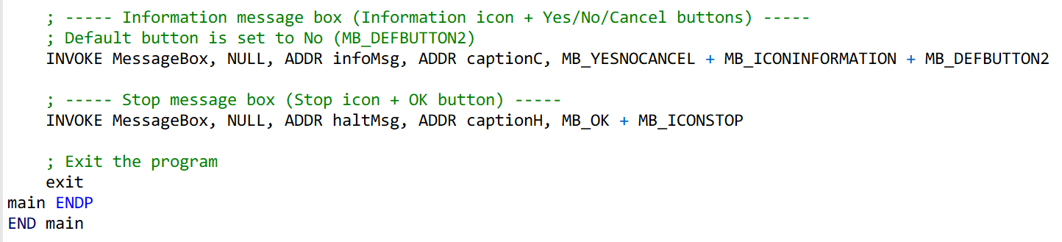

**Includes** Irvine32.inc which provides macros like INVOKE and constants for Win32 API.

**.data section** defines captions and messages for each message box, null-terminated.

**main PROC** is the entry point where all message boxes are displayed:

* MessageBox is called with parameters: hWnd, message, caption, and type (uType).
* uType combines **buttons** + **icons** + optional **default button**.

The **return value in eax** indicates which button the user clicked:

* IDYES → Yes
* IDNO → No
* IDCANCEL → Cancel

After all message boxes are shown, the program exits cleanly.

CONSOLE INPUT

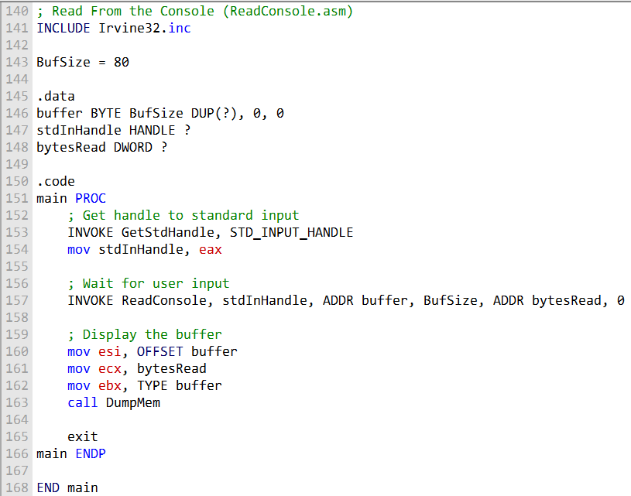

In Win32 console programming, there is a **console input buffer** that stores **input event records** (keystrokes, mouse movements, and mouse clicks).

**High-level input functions**, like ReadConsole, process these events and return a **stream of characters** to the program.

**ReadConsole function**:

* Reads text input from the console and stores it in a buffer.
* Parameters include:
  + Console input handle
  + Pointer to a character buffer
  + Number of characters to read
  + Pointer to store the count of characters read
  + Reserved parameter (must be 0)

Example program workflow:

* Defines **buffer size** (BufSize) and declares necessary data variables:
  + Buffer for storing input
  + Handle for standard input (stdInHandle)
  + Variable for number of bytes read (bytesRead)
* Retrieves **standard input handle** using GetStdHandle.
* Calls **ReadConsole** to read input from the user.
* Parameters include standard input handle, buffer, max characters to read, pointer for characters read, and reserved value 0.

After reading input, the program displays the buffer content using **DumpMem** (from Irvine32 library), showing both **hexadecimal and ASCII representations**.

The program can display **all user input**, including end-of-line characters (0Dh and 0Ah) from pressing Enter.

CHECKING FOR ERRORS

Read the **GetLastError.asm** file, no need to yap😂

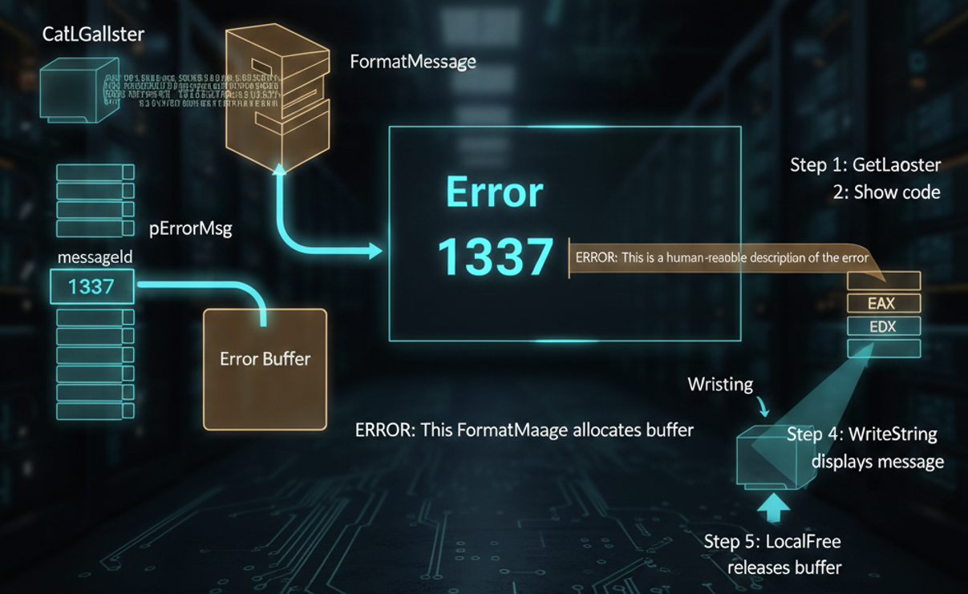

SINGLE CHARACTER INPUT

**Single-Character Input and Irvine32 Keyboard Procedures**

When working in **console mode** on Windows, reading a single character from the keyboard involves a few layers: the keyboard device driver, scan codes, virtual-key codes, and the program’s message queue.

Here’s a breakdown of how it works and how the Irvine32 library helps simplify it.



How Keyboard Input Works in Windows

1. **Key Press**  
   When you press a key, the keyboard device driver sends an **8-bit scan code** to the computer. This code tells the system which physical key was pressed.
2. **Key Release**  
   Releasing the key sends a second scan code.
3. **Translation to Virtual-Key Codes**  
   Windows converts these scan codes into **16-bit virtual-key codes**.  
   Virtual-key codes are **device-independent**, meaning they identify the key’s purpose (like VK_UP for the Up Arrow) rather than its physical location.
4. **Message Queue**  
   Windows creates a message containing the scan code, virtual-key code, and related info.  
   This message is placed in the program’s **message queue**.
5. **Program Access**  
   The console program eventually retrieves the message using the **console input handle**.

Irvine32 Keyboard Procedures

The **Irvine32 library** provides two main procedures to make keyboard input much easier:

ReadChar  
Waits for a key to be typed and returns its ASCII value in the AL register.

ReadKey  
Checks for a keypress **without waiting**.

* If no key is pressed, the **Zero Flag** is set.
* If a key is pressed:
  + Zero Flag is clear
  + AL contains either an ASCII code or zero (for special keys)
  + Upper halves of EAX and EDX are overwritten

Handling Special Keys with ReadKey

* If AL is zero, the key is a **special key** (like a function key or arrow key).
* AH contains the **scan code** for the key.
* DX contains the **virtual-key code**.
* EBX contains **control key state information**.

Control Key State Values in EBX

You can check EBX to see which control keys are active:

* CAPSLOCK_ON – CapsLock is on
* NUMLOCK_ON – NumLock is on
* SCROLLLOCK_ON – Scroll Lock is on
* SHIFT_PRESSED – Shift key is pressed
* LEFT_ALT_PRESSED / RIGHT_ALT_PRESSED – Alt key pressed
* LEFT_CTRL_PRESSED / RIGHT_CTRL_PRESSED – Ctrl key pressed
* ENHANCED_KEY – Key is enhanced (special function)

These constants let you **respond to user actions** precisely.



Testing Keyboard Input

Using ReadKey

You can write a simple test program:

1. Call ReadKey (optionally with a delay to allow Windows to process its message loop).
2. If a key is pressed (ReadKey returns non-zero):
   * Check EBX using constants like CAPSLOCK_ON
   * Display whether CapsLock (or other keys) is ON or OFF

This helps verify that your keyboard input handling works correctly.



Using GetKeyState

* GetKeyState is a **Win32 API function** that lets you test **the current state of any individual key**.
* Pass it a **virtual-key code** (like VK_CAPITAL for CapsLock or VK_NUMLOCK for NumLock).
* It returns the key’s state (pressed, toggled, etc.) so your program can react accordingly.



Summary

* **ReadChar** → wait for a single ASCII character
* **ReadKey** → check immediately for keypress, including special keys
* **EBX & control key constants** → lets you detect Shift, Ctrl, Alt, CapsLock, and more
* **GetKeyState** → check the state of any key at any time

Using these procedures, your assembly programs can **easily handle single-character input**, detect special keys, and respond to the state of control keys in real time.

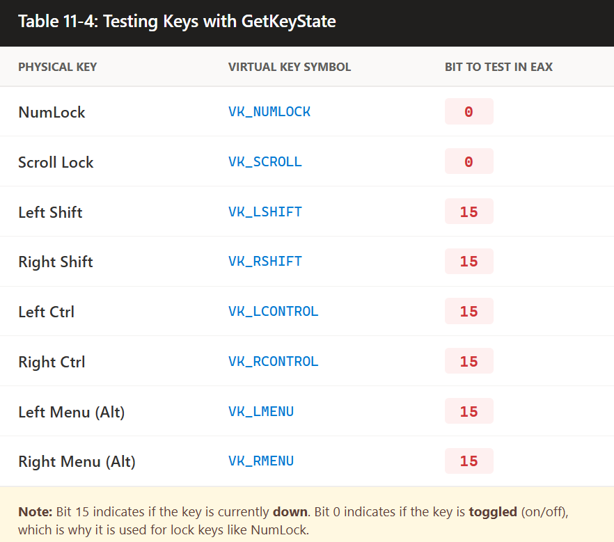

GetKeyState returns a value in **EAX**, which can be tested to determine the state of a key.

The program demonstrates checking the **NumLock** and **Left Shift** keys.

To check **NumLock**:

* Call GetKeyState with VK_NUMLOCK.
* Test **bit 0 (lowest bit) of AL**.
* If set, **NumLock is ON**.

To check **Left Shift**:

* Call GetKeyState with VK_LSHIFT.
* Test **bit 31 (highest bit) of EAX**.
* If set, the **Left Shift key is currently pressed**.

The program displays **messages** based on the test results to report the state of the keys.

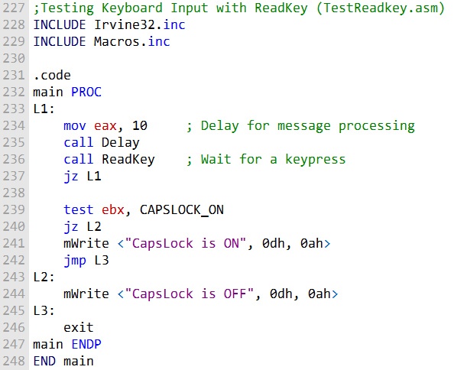

Program 2:

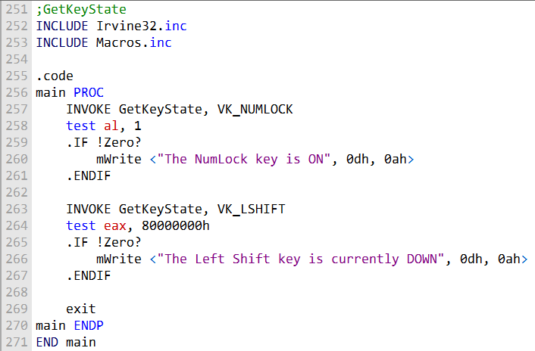

CONSOLE OUTPUT

I. WriteConsole Function

* Used to **write a string to the console** at the current cursor position.
* **Parameters**:
  + hConsoleOutput: Handle to the console output stream.
  + lpBuffer: Pointer to the array of characters to write.
  + nNumberOfCharsToWrite: Number of characters to write.
  + lpNumberOfCharsWritten: Pointer to receive the number of characters actually written.
  + lpReserved: Not used; set to 0.
* Advances the cursor just past the last character written.
* Can handle ASCII control characters (tabs, carriage returns, line feeds).
* The string **does not need to be null-terminated**.

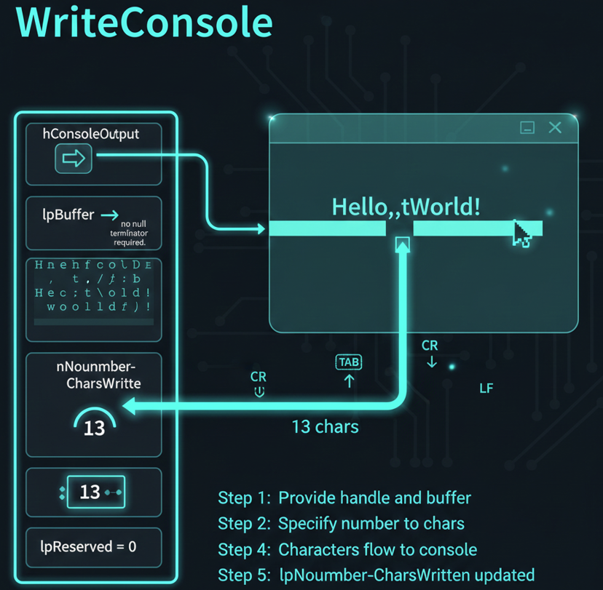

II. COORD Structure

Represents the **coordinates of a character cell** in the console screen buffer.

Origin is at the **top-left** of the console screen.

**Fields**:

* X (WORD): X-coordinate.
* Y (WORD): Y-coordinate.

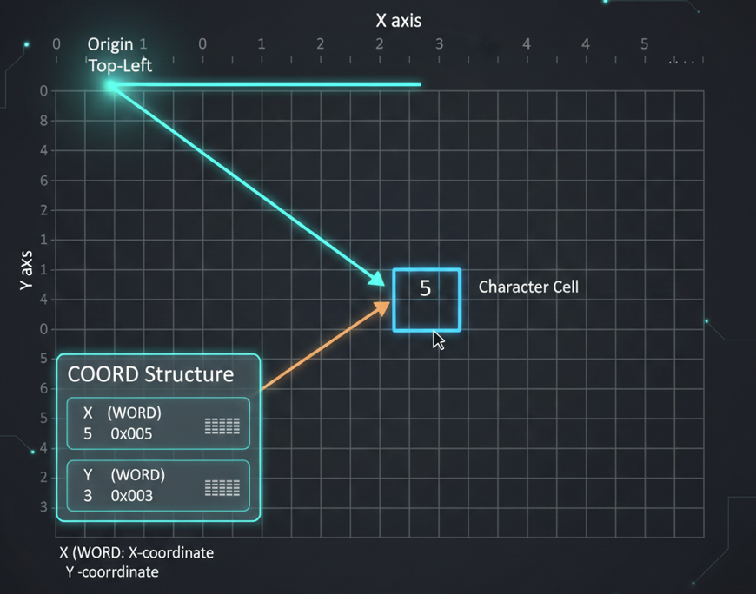

III. SMALL_RECT Structure

* Represents a **rectangular region** within the console window.
* Specifies **upper-left and lower-right corners** of the rectangle.
* Useful for defining **character cell regions** in the console.
* **Fields**:
  + Left (WORD): Left coordinate.
  + Top (WORD): Top coordinate.
  + Right (WORD): Right coordinate.
  + Bottom (WORD): Bottom coordinate.

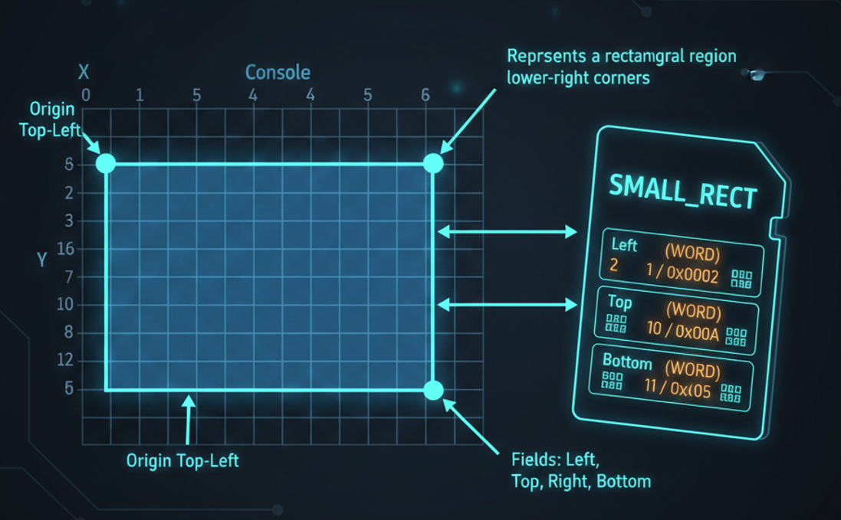

These structures are commonly used in **console-related Win32 functions** for managing and manipulating console windows.

WriteConsole is especially useful for **directly writing content to the console**.

***Example 1: WriteConsole function***

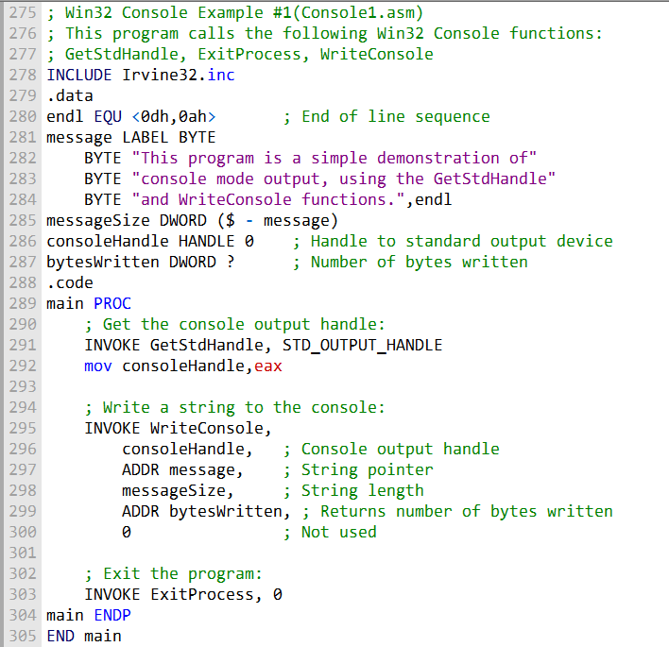

Console1.asm Program Overview

Demonstrates **GetStdHandle**, **WriteConsole**, and **ExitProcess** in a Win32 console application.

.data Section

* endl: End-of-line sequence (carriage return + line feed).
* message: Multiline text string to write to the console.
* messageSize: Stores the size of the message string.
* consoleHandle: HANDLE variable (initialized to 0) to store standard output handle.
* bytesWritten: DWORD variable to store the number of bytes written by WriteConsole.

.code Section (main procedure)

* INVOKE GetStdHandle, STD_OUTPUT_HANDLE:
  + Retrieves the handle to the standard output (console).
  + Stores the handle in consoleHandle.
* INVOKE WriteConsole:
  + Writes the message string to the console.
  + Parameters:
    - consoleHandle: Console output handle
    - ADDR message: Pointer to the message string
    - messageSize: Length of the message
    - ADDR bytesWritten: Pointer to receive number of bytes written
    - 0: Unused parameter
* INVOKE ExitProcess, 0: Exits the program.

Program Behavior

* Writes the message string to the console.
* Displays multiline text in the console window.
* Exits cleanly after writing the message.

The output will look like this:

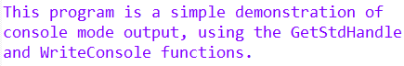

This code demonstrates how to use the **Win32 Console functions** to write a message to the console window.

The message is stored in the message variable and is written to the console using the **WriteConsole function**. Finally, the program exits using ExitProcess.

WriteConsoleOutputCharacter function - Writing to the Console Using Win32 Functions

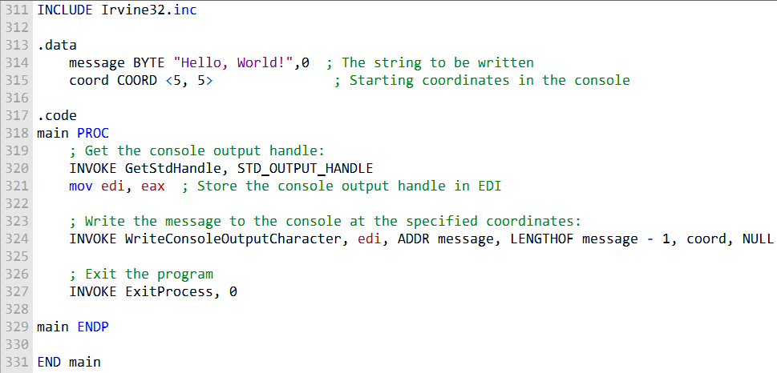

* **Purpose**: Demonstrates writing messages to the console window in a Win32 program.
* **Message Storage**: The message is stored in a variable (e.g., message).

WriteConsole Function

* Writes a string to the console at the **current cursor position**.
* Handles standard ASCII control characters like **carriage return (CR)** and **line feed (LF)**. Parameters:
  + hConsoleOutput: Handle to the console output.
  + lpBuffer: Pointer to the string to write.
  + nNumberOfCharsToWrite: Number of characters to write.
  + lpNumberOfCharsWritten: Pointer to receive the number of characters actually written.
  + lpReserved: Not used; set to 0.
* **Use Case**: Simple console output, writing sequentially from the current cursor position.

WriteConsoleOutputCharacter Function

* Writes an array of characters to **specific cells** in the console screen buffer.
* Text can wrap to the next line if it reaches the end of a line.
* **Does not** modify attribute values in the screen buffer.
* **Ignores ASCII control codes** like tab, CR, and LF.
* Parameters:
  + hConsoleOutput: Handle to the console output buffer.
  + lpCharacter: Pointer to the characters to write.
  + nLength: Number of characters to write.
  + dwWriteCoord: Coordinates (COORD structure) of the first cell to start writing (X = column, Y = row).
  + lpNumberOfCharsWritten: Pointer to receive the number of characters actually written.
* Return value: **Non-zero** if successful. **Zero** if failed.
* **Use Case**: Provides **precise control** over where text appears in the console, unlike WriteConsole.
* **ExitProcess Function -** Exits the program cleanly after writing messages.

FILE HANDLING

CreateFile Function

Creates a new file or opens an existing file.

Return Value:

* Returns a **handle** to the file if successful.
* Returns **INVALID_HANDLE_VALUE** if it fails.

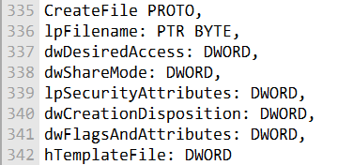

Parameters

1. **lpFilename**
   * Pointer to a null-terminated string with the file path.
   * Can be full path (C:\folder\file.txt) or just a filename (file.txt).
2. **dwDesiredAccess**
   * Specifies type of access to the file. Options include:
     + GENERIC_READ – read access
     + GENERIC_WRITE – write access
     + 0 – device query access
   * Flags can be combined with bitwise OR.
3. **dwShareMode**
   * Controls how other processes can access the file while it’s open:
     + FILE_SHARE_READ – others can read
     + FILE_SHARE_WRITE – others can write
     + 0 – no sharing
4. **lpSecurityAttributes**
   * Pointer to security structure. Usually NULL if no special security is needed.
5. **dwCreationDisposition**
   * Specifies action depending on file existence:
     + CREATE_NEW – create new, fails if exists
     + CREATE_ALWAYS – create new, overwrite if exists
     + OPEN_EXISTING – open existing, fails if not found
     + OPEN_ALWAYS – open if exists, create if not
     + TRUNCATE_EXISTING – open and truncate to zero, fails if not found
6. **dwFlagsAndAttributes**
   * File attributes and flags: e.g., FILE_ATTRIBUTE_NORMAL, FILE_ATTRIBUTE_HIDDEN, FILE_ATTRIBUTE_ARCHIVE.
7. **hTemplateFile**
   * Optional handle to a template file. Can supply attributes and extended attributes. Usually set to NULL.

Usage Notes

* dwDesiredAccess and dwShareMode can be combined using **bitwise OR**.
* dwCreationDisposition is **critical** for controlling whether a file is created, overwritten, or opened.
* WriteFile and ReadFile typically follow CreateFile for I/O operations using the returned handle.

Here's an example of how you might use the CreateFile function in assembly language to create or open a text file and get a handle to it:

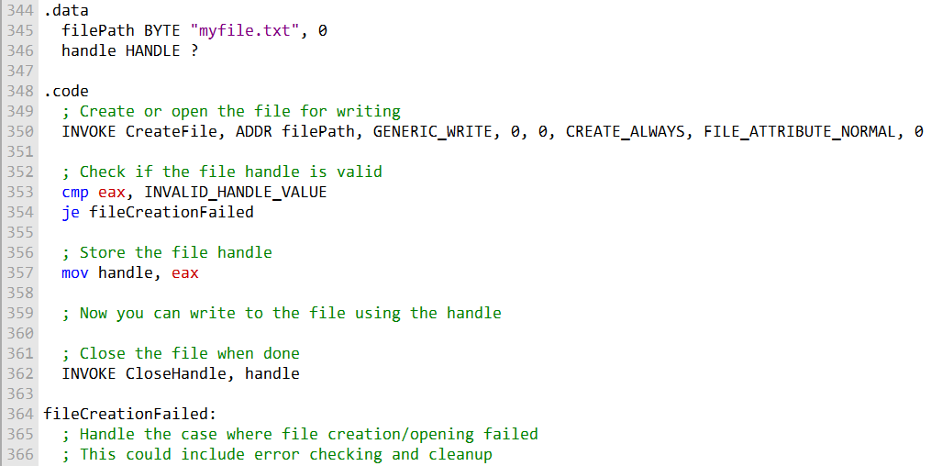

This code opens or creates the file "myfile.txt" for writing and checks if the operation was successful.

Combined Code:

Here's a single code example that demonstrates the creation and opening of files using CreateFile, and reading from a file using ReadFile.

It uses the file "mydata.txt" for illustration:

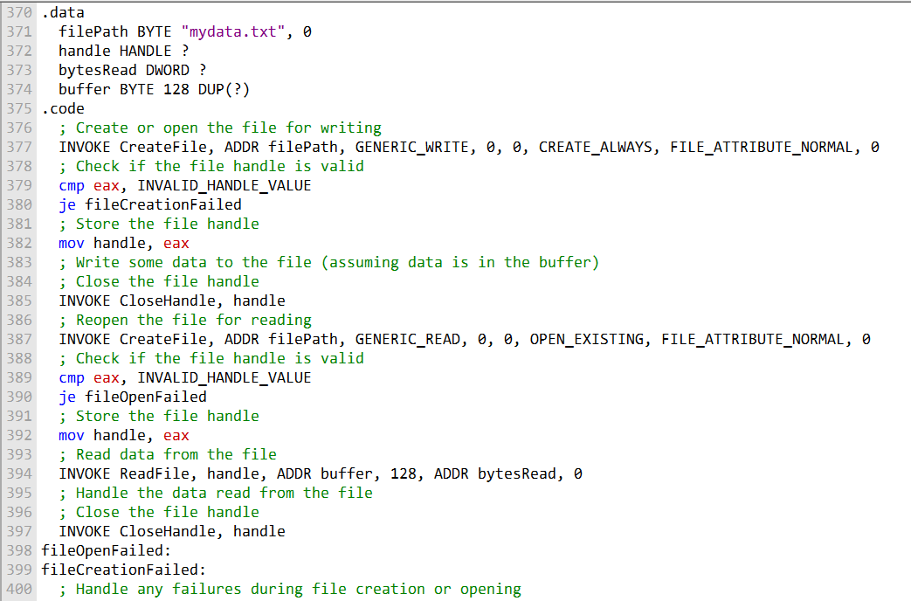

Things the User Can’t Read Directly from the Code and we have to explain:

* **CreateFile behavior**
  + Returns a **handle**, not the actual file contents; you need ReadFile or WriteFile to interact with data.
  + If it fails, INVALID_HANDLE_VALUE is returned, but **why it failed** isn’t obvious until you check GetLastError.
* **Access vs. sharing**
  + dwDesiredAccess only requests access; it does **not guarantee** other processes won’t access the file. That’s determined by dwShareMode.
  + Combining GENERIC_READ | GENERIC_WRITE doesn’t automatically prevent other processes from writing unless dwShareMode is set to restrict it.
* **Security attributes**
  + lpSecurityAttributes controls inheritance and permissions at the system level.
  + Even if set to NULL, default security rules apply, which might block access depending on the user or process permissions.
* **Creation disposition subtleties**
  + CREATE_NEW ensures you never overwrite existing files.
  + OPEN_ALWAYS can **both open or create** a file, which can lead to unexpected behavior if the file already exists.
  + TRUNCATE_EXISTING destroys the file’s previous content immediately; there’s no undo.
* **File attributes (dwFlagsAndAttributes)**
  + Attributes like FILE_ATTRIBUTE_HIDDEN or FILE_ATTRIBUTE_READONLY don’t prevent access programmatically but affect how the file is treated by the OS and some applications.
* **Template file (hTemplateFile)**
  + Rarely used, but if specified, new files can inherit extended attributes (like NTFS alternate data streams) from the template.
* **Closing files**
  + CloseHandle isn’t just cleanup—it flushes buffers and ensures **data integrity**. Forgetting to close a handle can corrupt files or leak system resources.
* **ReadFile behavior**
  + Synchronous vs asynchronous reading: lpOverlapped = NULL makes it synchronous.
  + The function fills a buffer and reports exactly how many bytes were read, which may be **less than requested** at the end of the file.
* **Error handling**
  + Most failures don’t crash the program—they require GetLastError to understand the cause (e.g., access denied, file not found, sharing violation).

WRITEFILE AND SETFILEPOINTER

WriteFile function

The WriteFile function is used to **write data to a file or any output handle** (like a console or screen buffer).

I. How it works:  
The function writes data starting at the file’s **current position pointer**. After the operation, the pointer automatically moves forward by the number of bytes actually written.

II. Parameters:

* hFile – handle to the file or output destination
* lpBuffer – pointer to the data buffer to write
* nNumberOfBytesToWrite – how many bytes to write
* lpNumberOfBytesWritten – receives the actual number of bytes written
* lpOverlapped – set to NULL for synchronous writes; used for asynchronous operations

III. Return value:

* Non-zero → success
* Zero → failure (use GetLastError to find out why)

IV. Things to keep in mind:

* **Partial writes:** Even if you request nNumberOfBytesToWrite, fewer bytes may be written (e.g., disk full). Always check lpNumberOfBytesWritten.
* **Handles:** Can write not just to files, but also to pipes, consoles, or other output handles.
* **Synchronous vs. asynchronous:** Synchronous writes block the calling thread; asynchronous writes require OVERLAPPED.

SetFilePointer Function

SetFilePointer moves the **current read/write position** in an open file, which is useful for **random access or appending data**.

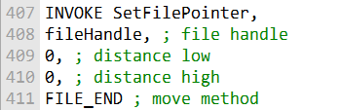

I. Parameters:

* hFile – handle to the open file
* lDistanceToMove – number of bytes to move the pointer (can be positive or negative)
* lpDistanceToMoveHigh – pointer to the high 32 bits of the distance (for files larger than 4 GB; use NULL if not needed)
* dwMoveMethod – starting point for the move:
  + FILE_BEGIN → absolute position from file start
  + FILE_CURRENT → relative to current pointer
  + FILE_END → relative to file end (easy for appending)

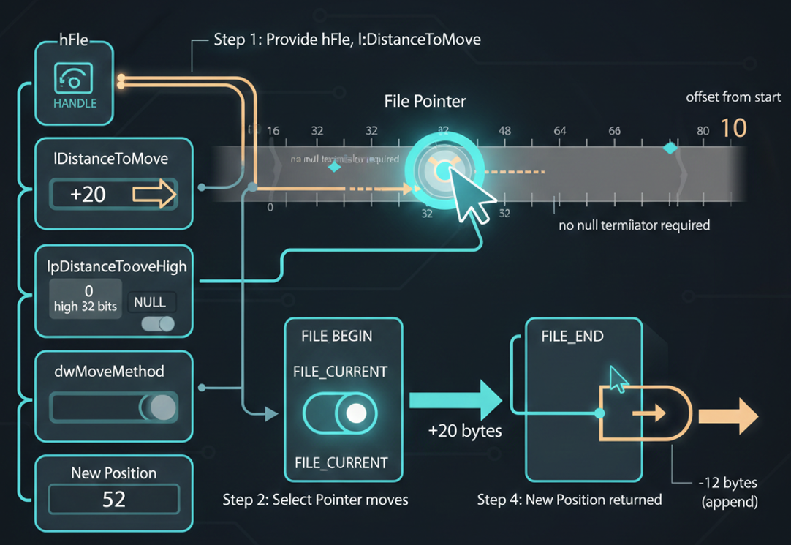

II. Hidden behaviors & tips:

* Moves the file’s **internal pointer**, which affects all subsequent ReadFile and WriteFile calls.
* Can handle **large files** via lpDistanceToMoveHigh.
* Supports **negative offsets** to move backward in the file.
* If the pointer cannot be set (e.g., negative position before file start), the function returns INVALID_SET_FILE_POINTER; call GetLastError to get details.

III. Quick Usage Example

**Appending data to a file:**

Move to the end of the file:

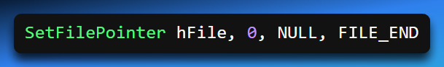

Write data:

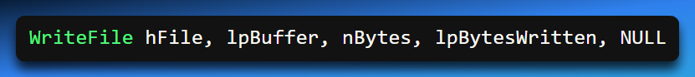

The file pointer automatically advances after the write.

These functions are essential for managing file access and writing data in Windows programming.

They are typically used in sequence:

* **SetFilePointer** positions the file pointer to the desired location.
* **WriteFile** writes data to that specific location.

Proper use of these functions ensures efficient and accurate file manipulation in Windows applications.

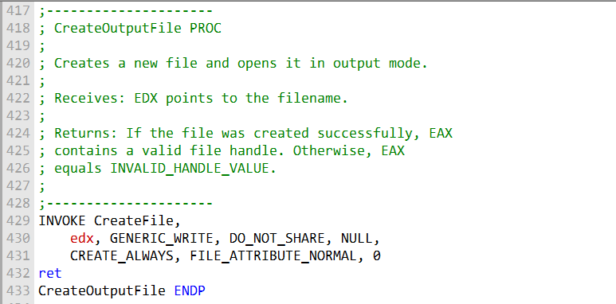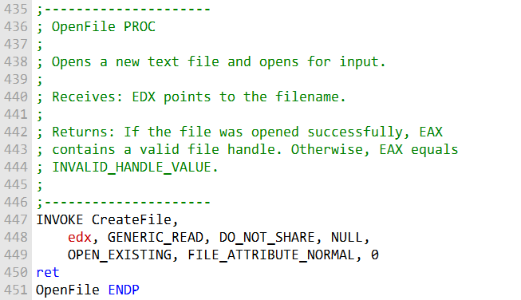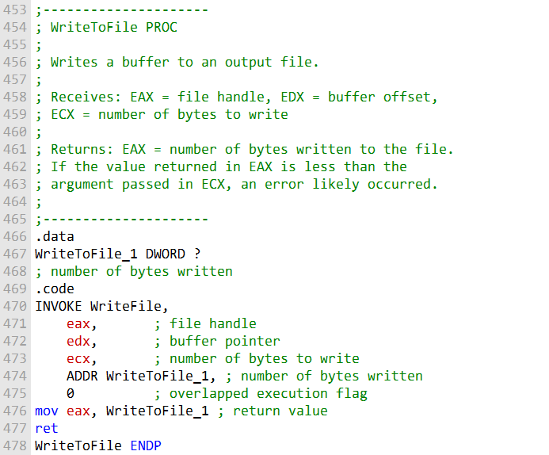

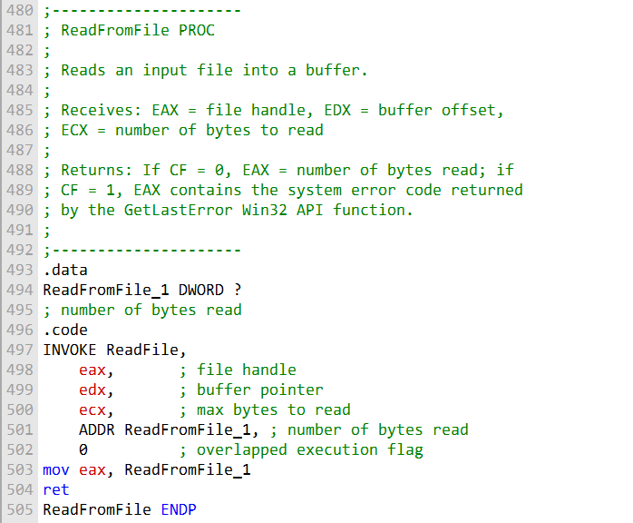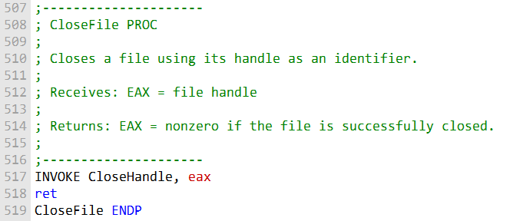

That was the first program to test your knowledge, now let's do the second one:

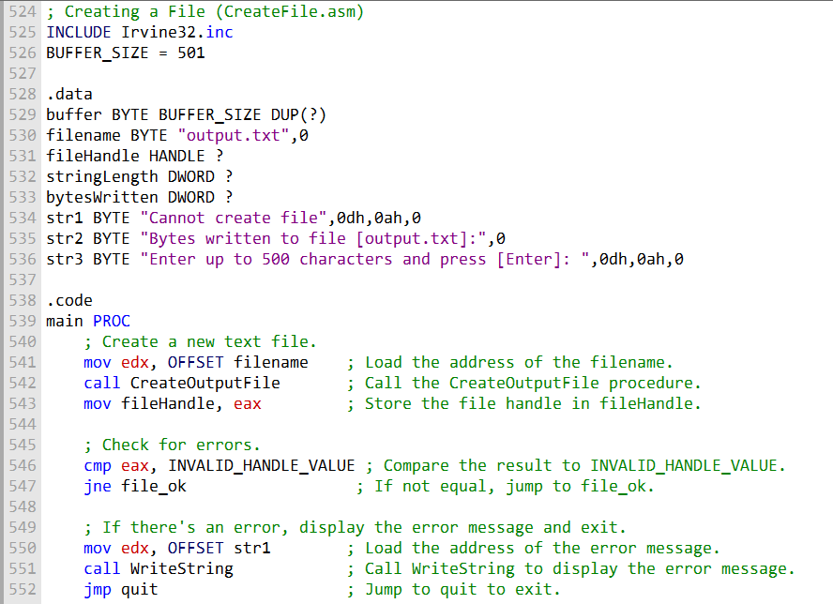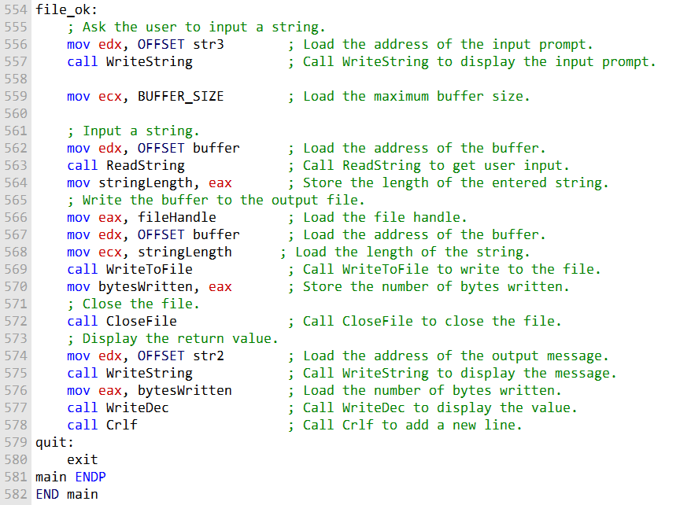

That's the second program.

Let's try another program:

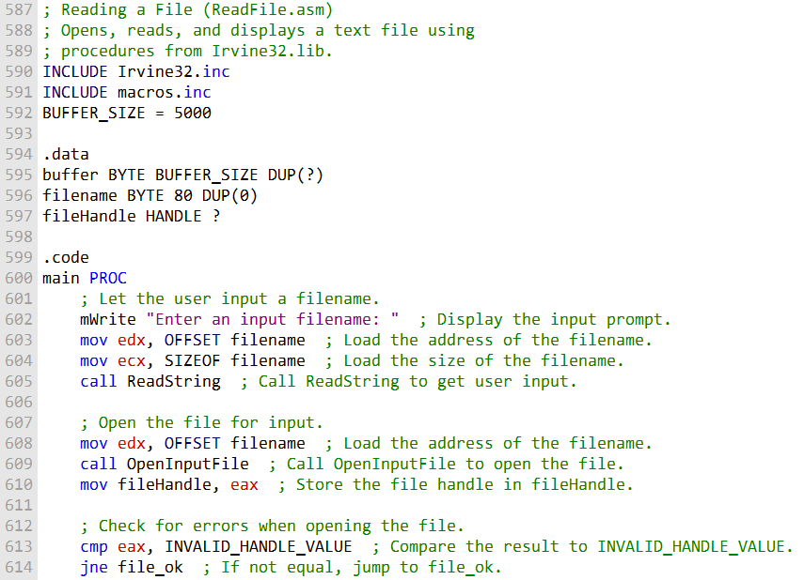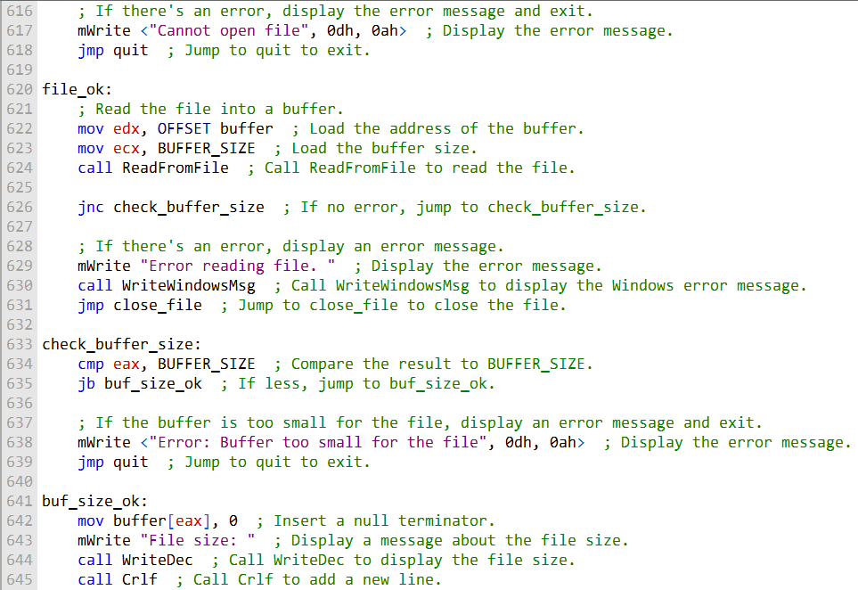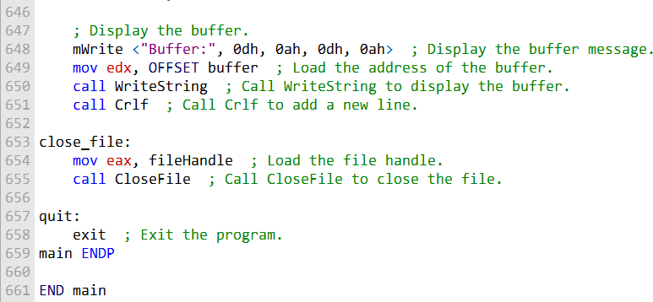

That's the 3rd program.

CONSOLE WINDOW MANIPULATION

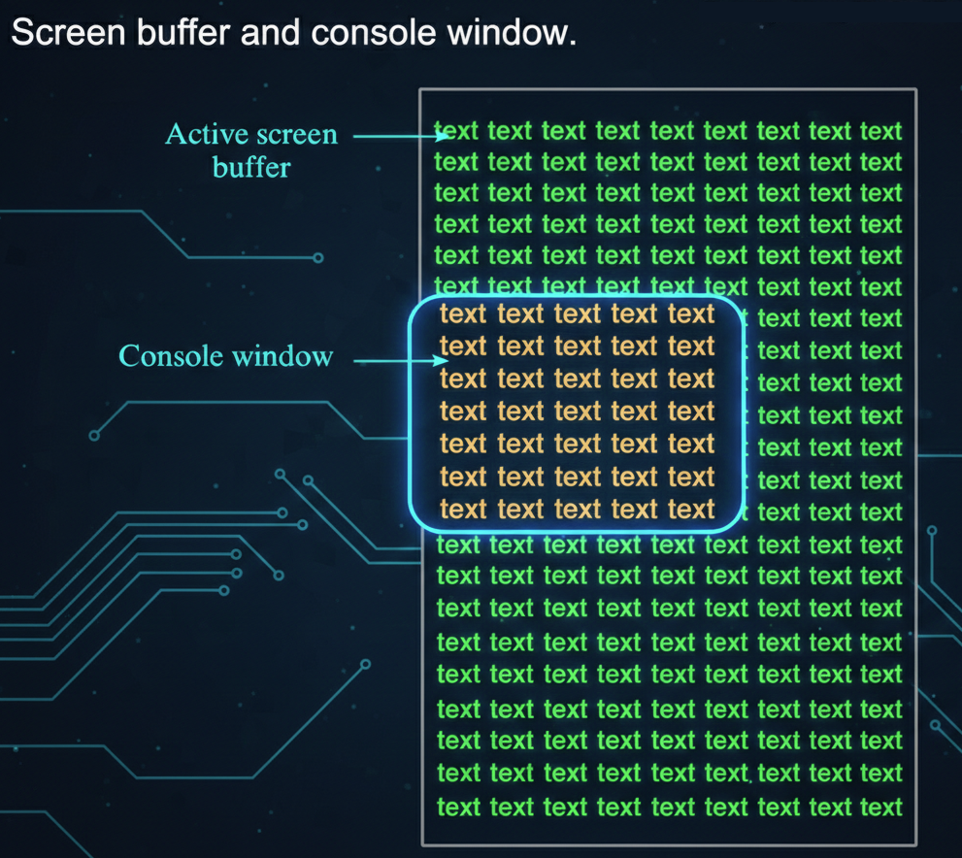

* **Screen Buffer:** Memory area storing characters and color attributes for the console.
* **Console Window:** The visible window displaying the contents of the screen buffer.

Key Functions

* **WriteConsoleOutput():**
  + Writes characters **and color attributes** to a rectangular block in the console buffer.
  + Can update a specific area without affecting the rest of the buffer.
* **ReadConsoleOutput():**
  + Reads characters **and color attributes** from a rectangular block in the console buffer.
  + Useful for saving or inspecting parts of the screen before modifying it.
* **SetConsoleCursorPosition():**
  + Moves the cursor to a specific location in the console buffer.
  + Affects where the next character will be displayed.

Screen Buffer Character Operations

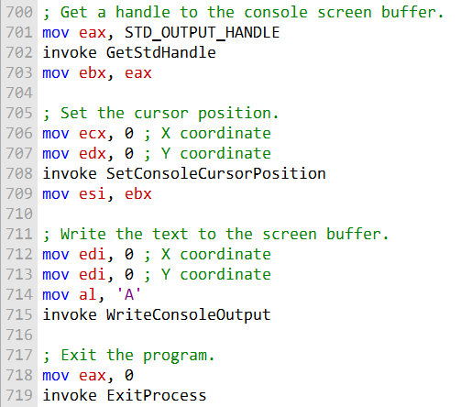

* Writing a character (e.g., 'A') to the **top-left corner** updates both the character and its color attribute in the screen buffer.
* The **cursor position is independent**—writing with WriteConsoleOutput doesn’t move the console cursor.
* Using **ReadConsoleOutput** allows you to read characters **and their color attributes** from any rectangular block of the screen buffer.
* These functions let you **manipulate the console display directly** without relying on high-level console output functions.
* Reading/writing is **coordinate-based**, using COORD structures for the X (column) and Y (row) positions.

Screen Buffer and Cursor Operations

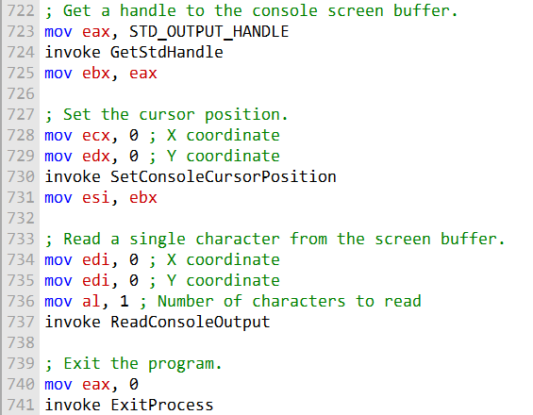

* **Reading a character:**
  + ReadConsoleOutput can retrieve a character **and its color attributes** from a specific location in the screen buffer.
  + Example: reading from the **top-left corner** fetches the first character displayed in the console.
* **Setting the cursor position:**
  + SetConsoleCursorPosition moves the cursor to any position in the screen buffer.
  + Example: setting it to the **middle of the console window** determines where the next character will appear when using functions like WriteConsole.
* These functions allow **direct manipulation of both content and cursor location**, independent of high-level output functions.
* Coordinates are handled using the **COORD structure** (X = column, Y = row).

SetConsoleCursorPosition – Middle of Console

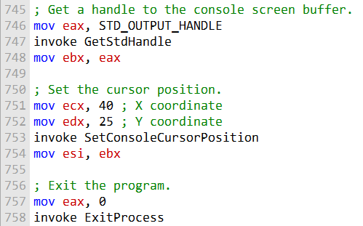

* The function moves the cursor to a **specific location** in the console buffer.
* To place it in the **middle of the console window**, you calculate coordinates as:
  + **X (column) = window width ÷ 2**
  + **Y (row) = window height ÷ 2**
* This determines **where the next character output will appear**.
* It does **not write any characters itself**; it only positions the cursor.
* Useful for **centering text** or controlling text layout precisely in console applications.

SetConsoleTitle, GetConsoleScreenBufferInfo, and SetConsoleWindowInfo

I. SetConsoleTitle

* Changes the **title of the console window**.
* You provide a string containing the new title.
* **Use case:** Customize the window title to reflect the program’s state or purpose.

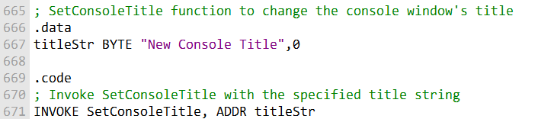

II. GetConsoleScreenBufferInfo

* Retrieves detailed information about the console window and screen buffer.
* Information is stored in a structure, typically named consoleInfo, which includes:
  + Size of the screen buffer
  + Current cursor position
  + Window dimensions
  + Text attributes
* **Use case:** Determine console layout, cursor location, or buffer size before performing advanced output operations.
* **Code can be inserted here** to call GetConsoleScreenBufferInfo and fill the consoleInfo structure.

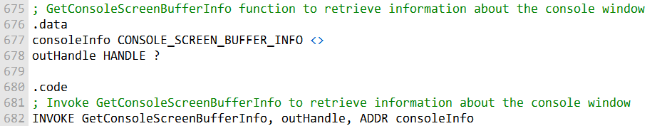

This code shows how to use the **GetConsoleScreenBufferInfo function** to obtain information about the console window, including screen buffer size, cursor position, and other details. The retrieved information is stored in the consoleInfo structure.

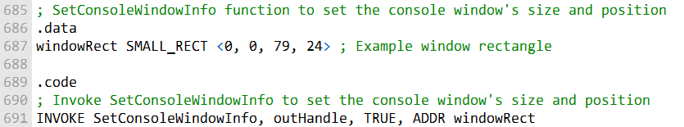

III. SetConsoleWindowInfo

* Sets the **size and position** of the console window relative to its screen buffer.
* You define the new dimensions and location using a structure, typically called windowRect.
* **Use case:** Resize or reposition the console window for better text layout or UI alignment.
* **Code can be inserted here** to call SetConsoleWindowInfo with the desired window rectangle.

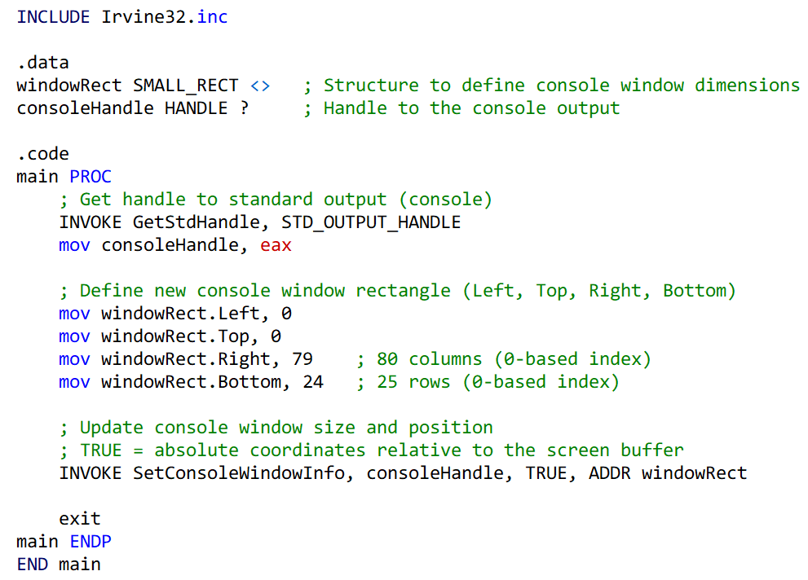

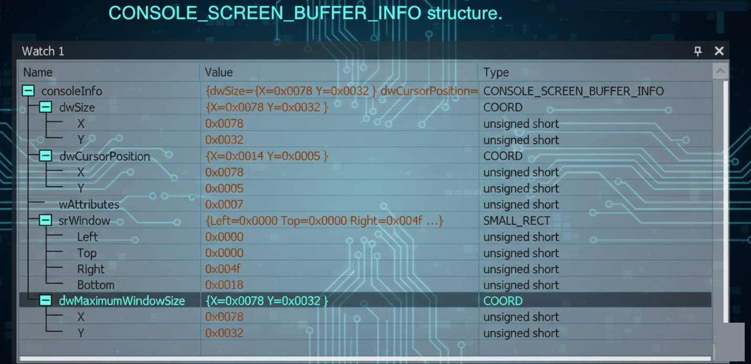

Scroll.asm program:

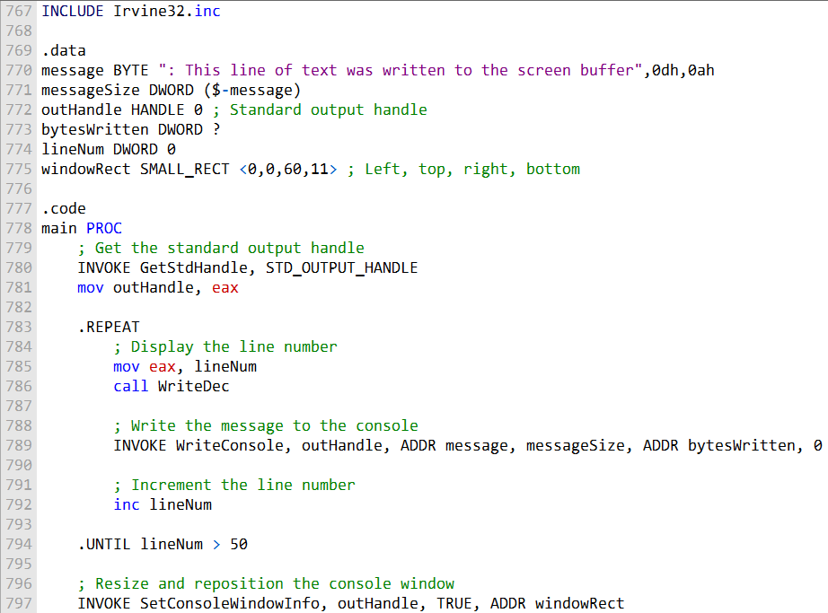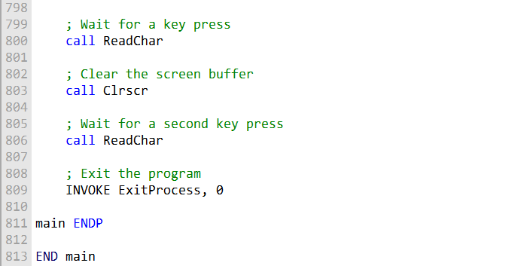

This code simulates scrolling the console window by writing lines of text to the screen buffer and then resizing and repositioning the console window using SetConsoleWindowInfo.

After running this program, press a key to trigger the scroll, clear the screen, and exit the program.

Another example:

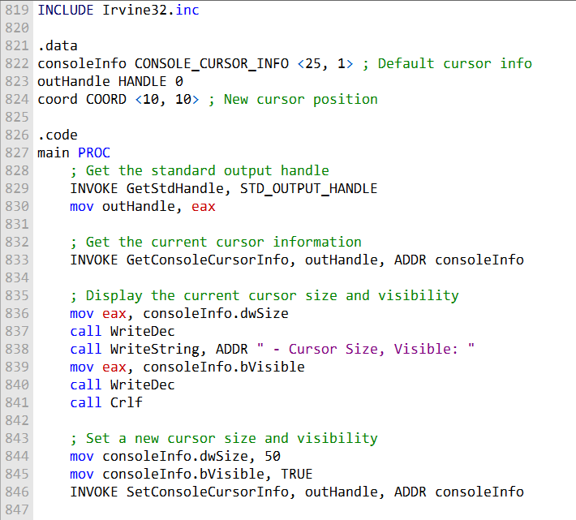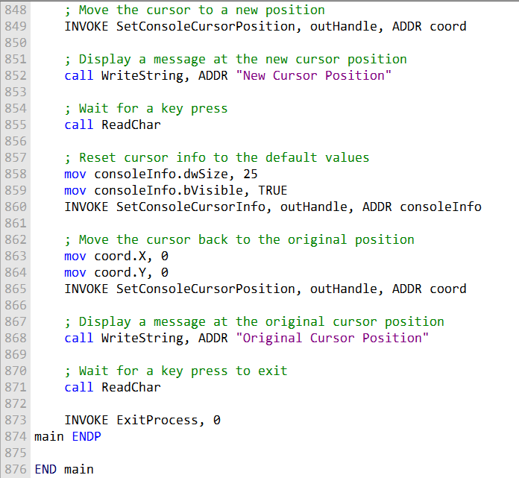

Summary of that program:

* **Retrieve current cursor info:** Uses GetConsoleCursorInfo to store the current size and visibility of the cursor.
* **Change cursor appearance:** Modifies cursor size and visibility using SetConsoleCursorInfo.
* **Move the cursor:** Uses SetConsoleCursorPosition to position the cursor at a new location in the console window.
* **Display message:** Writes text to the console at the new cursor position.
* **Restore original cursor:** Resets the cursor size and visibility to the values retrieved at the start.
* **Wait for key press:** Pauses the program using a key press before exiting, ensuring the user can see the results.

SETTING TEXT COLOR

SetConsoleTextAttribute

* Sets the foreground and background colors for all text written afterward.
* Requires the console output handle and a combined color attribute.
* Changes apply to subsequent text output until another color change.

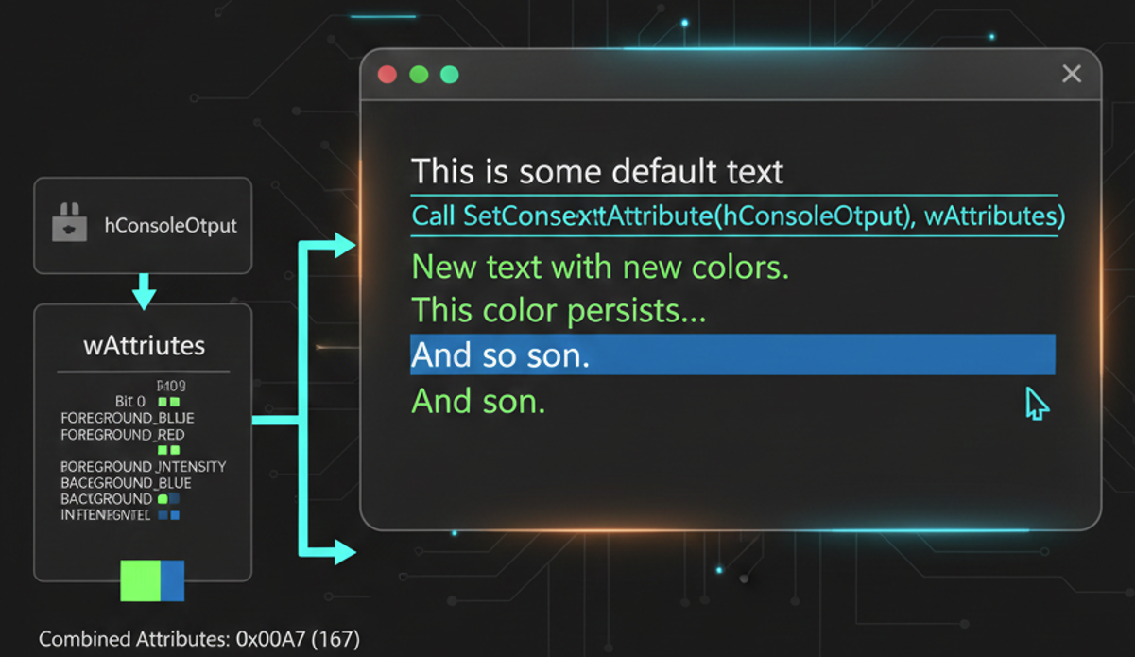

WriteConsoleOutputAttribute

* Sets text attributes (like color) for specific cells in the console screen buffer.
* Requires: an array of attributes, the number of attributes, starting coordinates (COORD), and a variable to receive the count of cells modified.
* Allows fine-grained control over colors of individual characters rather than the whole output.

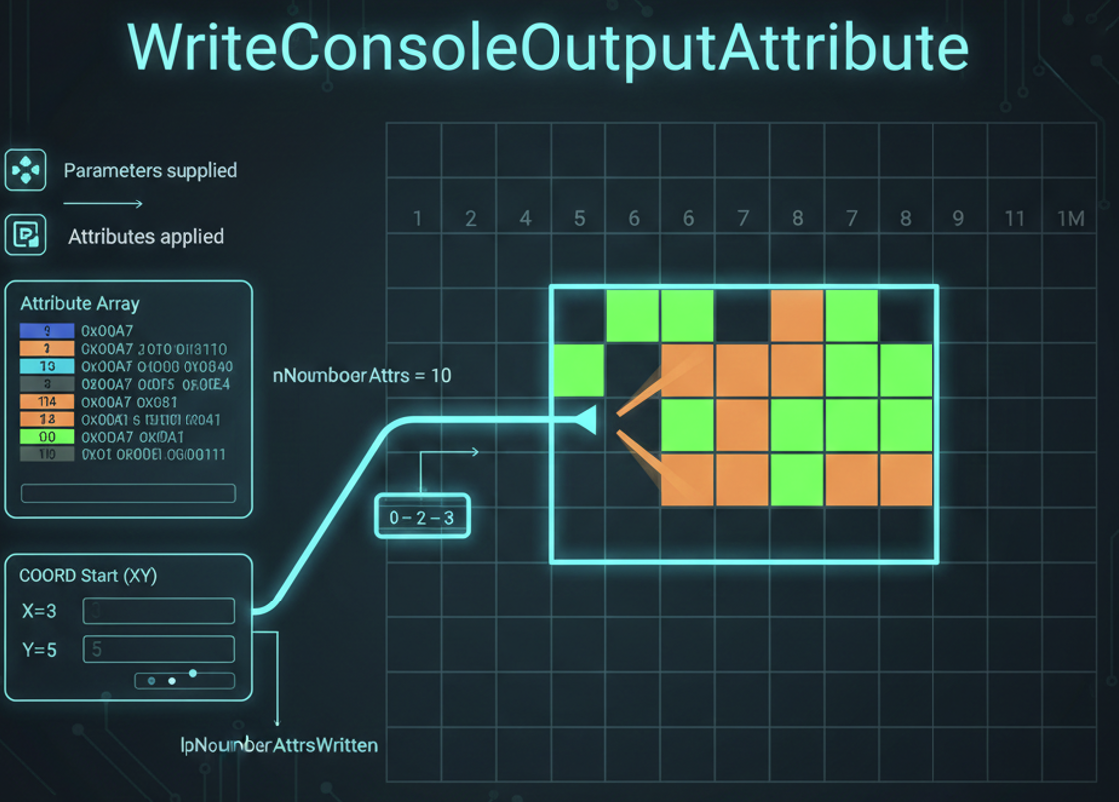

Use Case / Example Program

* Display different characters with varying colors.
* Can mix foreground and background colors for emphasis or visual effects.
* Useful for creating colored menus, status bars, or highlighting in console apps.

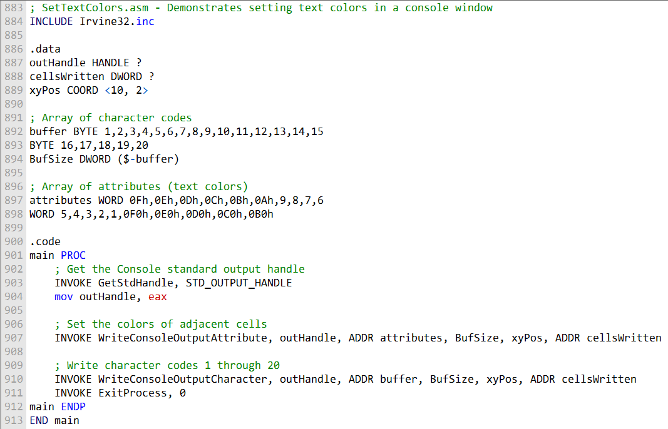

This program sets different text colors for characters 1 to 20 and displays them in a console window. The text colors are specified in the attributes array. The characters and their associated colors are written to the console screen buffer, resulting in colorful text output.

This program is a simple example to get you started with text color manipulation in a console window. You can modify the attributes array to set different colors for your text as needed.

TIME, WINAPI AND ASSEMBLY

Here's a brief description of each of the time and date-related functions in the Win32 API:

**CompareFileTime:**

Compares two 64-bit file times to determine their order.

**DosDateTimeToFileTime:**

Converts MS-DOS date and time values to a 64-bit file time, allowing easy compatibility with older date and time representations.

**FileTimeToDosDateTime:**

Performs the reverse operation, converting a 64-bit file time to MS-DOS date and time values.

**FileTimeToLocalFileTime:**

Converts a UTC (universal coordinated time) file time to a local file time, making it suitable for use in the local time zone.

**FileTimeToSystemTime:**

Converts a 64-bit file time to a SYSTEMTIME structure, providing detailed date and time information.

**GetFileTime:**

Retrieves the date and time when a file was created, last accessed, and last modified.

**GetLocalTime:**

Retrieves the current local date and time, useful for obtaining the current local system time.

**GetSystemTime:**

Retrieves the current system date and time in UTC format, allowing for consistent time information across different time zones.

**GetSystemTimeAdjustment:**

Determines whether the system is applying periodic time adjustments to its time-of-day clock, important for handling time adjustments like daylight saving time.

**GetSystemTimeAsFileTime:**

Retrieves the current system date and time in UTC format, providing a 64-bit file time.

**GetTickCount:**

Retrieves the number of milliseconds that have elapsed since the system was started, useful for measuring time intervals or system uptime.

**GetTimeZoneInformation:**

Retrieves the current time-zone parameters, allowing you to obtain information about the system's time zone.

**LocalFileTimeToFileTime:**

Converts a local file time to a file time based on UTC, enabling the conversion of local time to a more universal format.

**SetFileTime:**

Sets the date and time that a file was created, last accessed, or last modified, allowing for the modification of file timestamps.

**SetLocalTime:**

Sets the current local time and date on the system, making it useful for adjusting the system's local time settings.

**SetSystemTime:**

Sets the current system time and date, enabling adjustments to the system's time settings.

**SetSystemTimeAdjustment:**

Allows you to enable or disable periodic time adjustments to the system's time-of-day clock.

**SetTimeZoneInformation:**

Sets the current time-zone parameters, providing control over the system's time zone settings.

**SystemTimeToFileTime:**

Converts a SYSTEMTIME structure to a 64-bit file time, allowing for the transformation of detailed date and time information into a universal format.

**SystemTimeToTzSpecificLocalTime:**

Converts a UTC time to a specified time zone's corresponding local time, useful when you need to adjust time information to a specific time zone.

***Here's the combined MASM program that includes the SYSTEMTIME structure, GetLocalTime, SetLocalTime, and GetTickCount functions, as well as a stopwatch timer:***

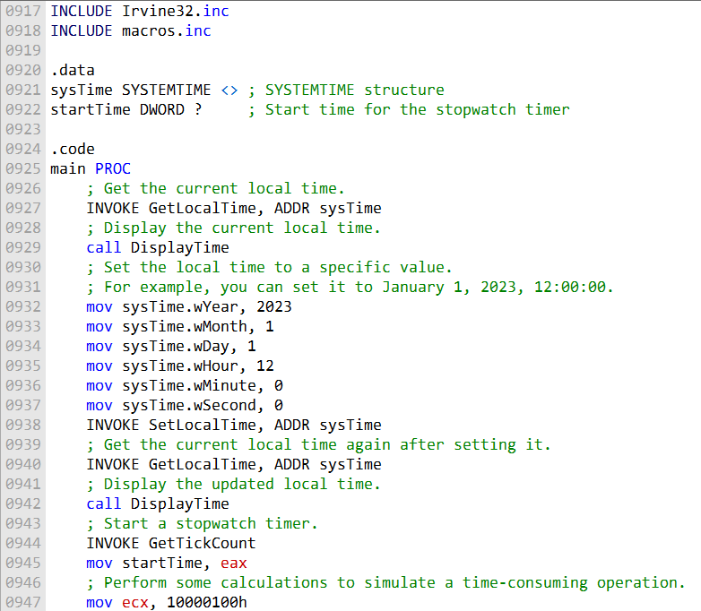

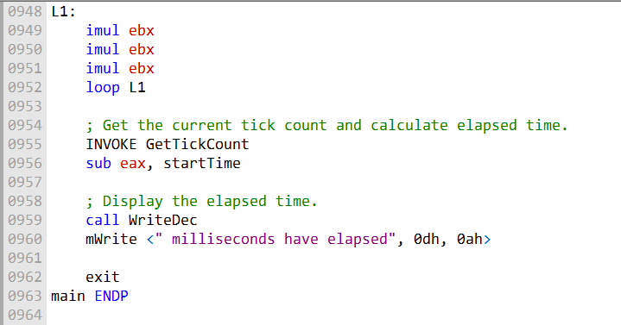

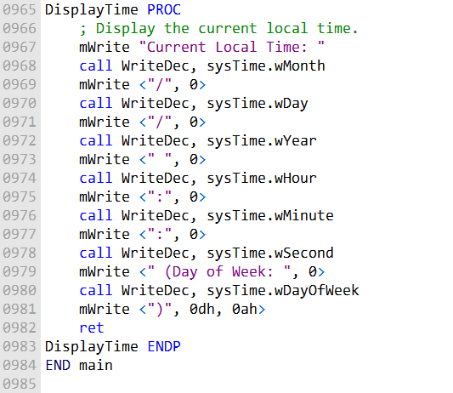

***Here's an explanation of the program in paragraph format:***

The program starts by defining a structure called SYSTEMTIME, which is used to hold information about date and time. It includes fields like year, month, day of the week, day of the month, hours, minutes, seconds, and milliseconds. This structure is essential for working with date and time-related functions in the Windows API.

The program utilizes the GetLocalTime function, a Windows API function that retrieves the current local date and time according to the system's clock. It takes a single parameter, a pointer to a SYSTEMTIME structure, where it stores the current date and time values. This function is essential for obtaining the current time for further processing.

On the other hand, the SetLocalTime function is another Windows API function used to set the system's local date and time. It also takes a SYSTEMTIME structure as a parameter, but this time, it contains the desired date and time values. By calling this function, you can modify the system's date and time settings programmatically.

The program also incorporates the GetTickCount function, which is used to measure the number of milliseconds that have passed since the system started. This function doesn't require any parameters and returns the elapsed time in the EAX register. It's particularly useful for timing operations and determining the duration of processes.

There's a custom procedure in the program called DisplayTime, which serves to display the various components of a SYSTEMTIME structure, such as the year, month, day, hour, minute, second, and day of the week. This procedure uses different write functions to display these components on the console.

The program's main procedure is the entry point. It first calls GetLocalTime to retrieve and display the current local time. After that, it sets the local time to a specific value, allowing you to modify the date and time as needed. The program then calls GetLocalTime again to retrieve and display the updated local time. To simulate a time-consuming operation, the program performs calculations in a loop. Before and after this loop, it uses GetTickCount to measure the elapsed time and displays it.

In summary, this program showcases how to work with date and time in a Windows environment using the SYSTEMTIME structure and relevant Windows API functions. It demonstrates retrieving and displaying the current local time, setting the local time, and measuring elapsed time using GetTickCount. You can adjust the date and time values as necessary for your specific requirements.

==========================================================

The **Sleep function** is a part of the Win32 API that allows programs to introduce pauses or delays. This can be useful for controlling the timing of various operations in a program.

The function takes a parameter that specifies the length of time to sleep, and then it puts the processor into a low-power state until the specified time has elapsed.

The **GetDateTime procedure** is a convenient utility to retrieve date and time information. It returns the number of 100-nanosecond intervals that have elapsed since January 1, 1601.

The procedure generally follows these steps:

It calls a function like GetLocalTime, which populates a SYSTEMTIME structure with the current date and time information.

It converts this SYSTEMTIME structure to a FILETIME structure using the SystemTimeToFileTime function. Then, it copies the resulting FILETIME structure to a 64-bit quadword.

The FILETIME structure is used to divide a 64-bit quadword into two doublewords.

The GetDateTime procedure, which receives a pointer to a 64-bit quadword variable as an argument, is responsible for storing the current date and time in the specified variable in the FILETIME format used by Win32.

In simpler terms, the **Sleep functio**n allows programs to pause for a specified period of time, while the **GetDateTime procedure** allows programs to retrieve the current date and time.

Both functions are useful for controlling the timing of various operations in Win32 applications.

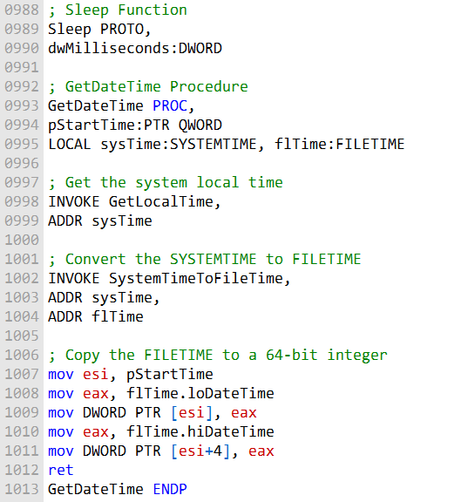

The Sleep function allows you to introduce time delays, and the GetDateTime procedure retrieves the current date and time and stores it in a 64-bit quadword. This code can be integrated into your assembly programs as needed.

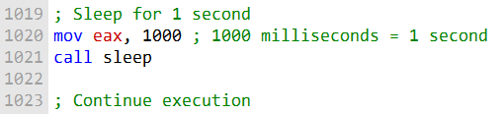

The eax register is used to specify the length of time to sleep. The call sleep instruction then calls the sleep function. Once the sleep function has returned, the program will continue execution.

It is important to note that the sleep function can be interrupted by certain events, such as a timer interrupt. If this happens, the program will resume execution immediately, even if the specified sleep time has not yet elapsed.

Here are some additional things to keep in mind when using the sleep function in MASM:

The sleep function is typically implemented as a system call.

This means that it must be executed in a privileged mode, such as kernel mode. The sleep function can be blocked by other processes.

This means that if another process is holding the kernel lock, the sleep function will not be able to execute until the other process releases the lock.

The sleep function can cause the processor to enter a low-power state. This can save power, but it can also delay the execution of other programs.

Overall, the sleep function is a powerful tool that can be used to control the execution of a program. However, it is important to be aware of the limitations of the function and to use it carefully.

CALLING 64-BIT WINAPI FUNCTION IN MASM

To call a 64-bit Windows API function in MASM, you must follow these steps:

Reserve at least 32 bytes of shadow space by subtracting 32 from the stack pointer (RSP) register.

Make sure RSP is aligned on a 16-byte address boundary.

Place the first four arguments in the following registers, from left to right:

RCX, RDX, R8, and R9.

Push additional arguments on the runtime stack.

Call the function using the call instruction.

Restore RSP to its original value by adding the same value to it that was subtracted before the function call.

The system function will return a 64-bit integer value in RAX. Here is an example of how to call the 64-bit WriteConsoleA function:

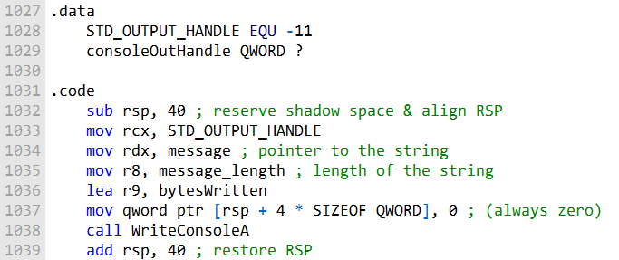

The WriteConsoleA function takes five arguments:

* The console handle.
* A pointer to the string to write.
* The length of the string to write.
* A pointer to the variable that will store the number of bytes written.
* A dummy zero parameter.
* The bytesWritten variable is used to store the number of bytes that were actually written.

Once you have called the WriteConsoleA function, you can check the value of the bytesWritten variable to see how many bytes were written.

***To write a graphical Windows application, you need to:***

**Include the necessary libraries and header files.** This includes the kernel32.lib and user32.lib libraries, as well as a header file that contains structures, constants, and function prototypes used by the program.

**Create a main window.** This is done using the CreateWindowEx() function. Display the main window. This is done using the ShowWindow() function. Respond to mouse events. This is done by handling the WM_MOUSEMOVE and WM_LBUTTONDOWN messages. Display message boxes. This is done using the MessageBox() function.

Here is a simple example of a graphical Windows application in assembly language:

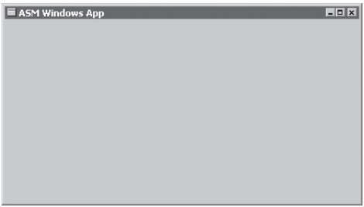

include "graphwin.inc"  
  
.data  
className db "WinApp", 0  
instance HANDLE  
window HANDLE  
  
.code  
start:  
 ; Register the window class  
 invoke RegClassEx, addr className  
  
 ; Create the main window  
 invoke CreateWindowEx, 0, addr className, addr className, WS_OVERLAPPEDWINDOW, 0, 0, CW_USEDEFAULT, CW_USEDEFAULT, HWND_DESKTOP, 0, instance, 0  
 **mov** window, eax  
  
 ; Show the main window  
 invoke ShowWindow, window, SW_SHOW  
  
 ; Message loop  
messageLoop:  
 invoke GetMessage, addr msg, 0, 0, 0  
 **cmp** eax, -1  
 **je** end  
  
 ; Translate and dispatch the message  
 invoke TranslateMessage, addr msg  
 invoke DispatchMessage, addr msg  
  
 **jmp** messageLoop  
  
end:  
 invoke ExitProcess, 0

This program creates a simple window with the title "WinApp". The window fills the screen and is centered on the desktop.

The program also handles mouse events and displays a message box when the user clicks the left mouse button.

To build and run the program, you can use the following steps:

Create a new assembly language project in Visual Studio. Add the following files to the project: WinApp.asm GraphWin.inc Add the kernel32.lib and user32.lib libraries to the project. Set the subsystem to Windows (/SUBSYSTEM:WINDOWS).

Build and run the program. When you run the program, you will see a simple window with the title "WinApp". If you click the left mouse button, the program will display a message box.

Ignore this program, it's just a trial program:

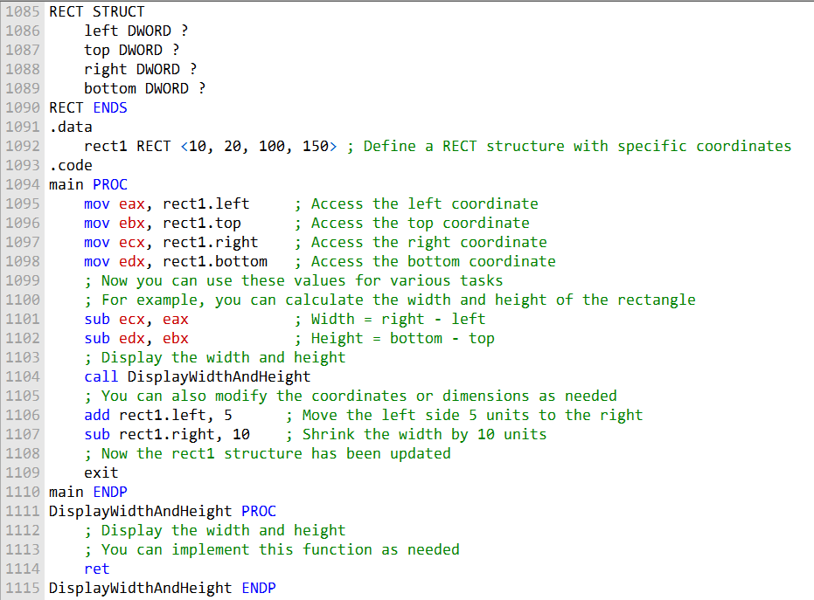

**Rectangle struct:** The RECT structure is used to define the boundaries of a rectangle. It includes four members that determine the position and size of the rectangle. The "left" member holds the X-coordinate of the left side of the rectangle, while the "top" member stores the Y-coordinate of the top side.

Similarly, the "right" and "bottom" members hold values for the right and bottom sides of the rectangle, respectively. Together, these members specify the dimensions and position of the rectangle on the screen.

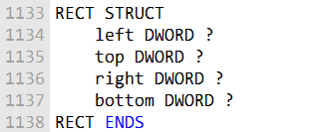

The **MSGStruct structure** defines the data needed for an MS-Windows message:

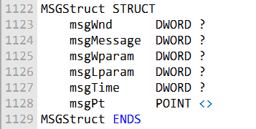

The **WNDCLASS structure** is used to define a window class in a Windows application. Every window within a program is associated with a specific class, and the program must register this class with the operating system before the main window can be displayed. Here is the WNDCLASS structure:

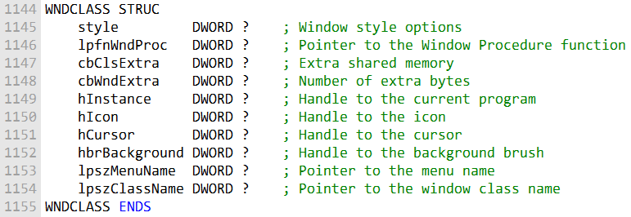

This structure holds various parameters and settings for a window class, including its appearance, behavior, and how it interacts with the operating system. Registering a window class allows the program to create and manage windows of that class.

***Here's a concise summary of the parameters within the WNDCLASS structure:***

**style:** A combination of style options, such as WS_CAPTION and WS_BORDER, that determine the window's appearance and behavior.

**lpfnWndProc:** A function pointer that specifies the program's function for processing event messages triggered by the user.

**cbClsExtra:** Refers to shared memory used by all windows belonging to the class, and it can be set to null if not needed.

**cbWndExtra:** Specifies the number of extra bytes to allocate following the window instance.

**hInstance:** Holds a handle to the current program instance, allowing the class to be associated with this instance of the program.

**hIcon and hCursor:** Hold handles to icon and cursor resources for the current program, influencing the visual elements used in the window.

**hbrBackground:** Holds a handle to a background brush, which determines the window's background color.

**lpszMenuName:** Points to a menu name, defining the menu associated with the window.

**lpszClassName:** Points to a null-terminated string containing the window's class name, allowing the program to identify and manage windows of this class effectively.

***The MessageBox Function***

The MessageBox function is the easiest way to display text in a Windows application. It displays a simple message box with a text message, a caption, and one or more buttons. The buttons can be used to get the user's response to the message.

***The WinMain Procedure***

The WinMain procedure is the startup procedure for every Windows application. It is responsible for the following tasks:

* Getting a handle to the current program.
* Loading the program's icon and mouse cursor.
* Registering the program's main window class and identifying the procedure that will process event messages for the window.
* Creating the main window.
* Showing and updating the main window.
* Beginning a loop that receives and dispatches messages.
* The loop continues until the user closes the application window.

***The WinProc Procedure***

The WinProc procedure receives and processes all event messages relating to a window.

Most events are initiated by the user by clicking and dragging the mouse, pressing keyboard keys, and so on.

The WinProc procedure's job is to decode each message, and if the message is recognized, to carry out application-oriented tasks relating to the message.

The following example code shows a simple Windows application that uses the MessageBox function to display a message to the user when the user clicks the left mouse button.

**#include <windows.h>**  
  
LRESULT CALLBACK WinProc(HWND hWnd, UINT uMsg, WPARAM wParam, LPARAM lParam)  
{  
 **switch** (uMsg) {  
 **case** WM_LBUTTONDOWN:  
 MessageBox(hWnd, "You clicked the left mouse button!", "Message Box Example", MB_OK);  
 **break**;  
 **case** WM_DESTROY:  
 PostQuitMessage(0);  
 **break**;  
 **default**:  
 **return** DefWindowProc(hWnd, uMsg, wParam, lParam);  
 }  
 **return** 0;  
}  
  
int WINAPI WinMain(HINSTANCE hInstance, HINSTANCE hPrevInstance, LPSTR lpCmdLine, int nCmdShow)  
{  
 WNDCLASSEX wc;  
 HWND hWnd;  
  
 // Register the window class.  
 wc.cbSize = sizeof(WNDCLASSEX);  
 wc.style = 0;  
 wc.lpfnWndProc = WinProc;  
 wc.cbClsExtra = 0;  
 wc.cbWndExtra = 0;  
 wc.hInstance = hInstance;  
 wc.hIcon = LoadIcon(**NULL**, IDI_APPLICATION);  
 wc.hCursor = LoadCursor(**NULL**, IDC_ARROW);  
 wc.hbrBackground = (HBRUSH)(COLOR_WINDOW + 1);  
 wc.lpszMenuName = **NULL**;  
 wc.lpszClassName = "MyWindowClass";  
  
 **if** (!RegisterClassEx(&wc)) {  
 **return** 0;  
 }  
  
 // Create a window.  
 hWnd = CreateWindowEx(0, "MyWindowClass", "Message Box Example", WS_OVERLAPPEDWINDOW, 100, 100, 300, 200, **NULL**, **NULL**, hInstance, **NULL**);  
 **if** (!hWnd) {  
 **return** 0;  
 }  
  
 // Show the window.  
 ShowWindow(hWnd, nCmdShow);  
 UpdateWindow(hWnd);  
  
 // Wait for a key press.  
 MSG msg;  
 **while** (GetMessage(&msg, **NULL**, 0, 0)) {  
 TranslateMessage(&msg);  
 DispatchMessage(&msg);  
 }  
  
 getchar(); // Wait for a key press  
 **return** msg.wParam;  
}

If you compile and run this code, you should see a window with the title "Message Box Example". Click the left mouse button in the window, and a message box should appear with the text "You clicked the left mouse button!".

It seems like you've provided a portion of code and information related to writing a graphical Windows application. This code appears to be written in assembly language, specifically designed for Windows programming. Here's a breakdown of the code and related information:

**ErrorHandler Procedure:** This procedure is called when an error occurs during the registration and creation of the program's main window. It performs several tasks, including retrieving the system error number, formatting the system error message, displaying it in a popup message box, and freeing the memory used by the error message string.

**Program Listing:** This part of the code defines various data structures and constants for the Windows application, such as window titles, messages, and class names. These are used throughout the application for display and interaction.

**MainWin WNDCLASS Structure:** It defines the window class structure for the application. It includes settings like window procedure, icon, cursor, and other attributes.

**WinMain Procedure:** This is the entry point of the application. It initializes various components, including registering the window class, creating the main window, displaying messages, and entering a message-handling loop.

**Message Handling Loop:** The code enters a continuous message-handling loop using GetMessage, processes messages with DispatchMessage, and continues until there are no more messages. When there are no more messages, it exits the program using ExitProcess.

This code is a part of a Windows application written in assembly language, which creates a main window, displays messages, and handles messages in a loop. If you have any specific questions or need further details about this code, please let me know, and I'll address them accordingly.

; Windows Application (WinApp.asm)  
; This program displays a resizable application window and  
; several popup message boxes. Special thanks to Tom Joyce  
; for the first version of this program.  
.386  
.model flat,STDCALL  
INCLUDE GraphWin.**inc**  
  
; ==================== DATA =======================  
.data  
AppLoadMsgTitle BYTE "Application Loaded",0  
AppLoadMsgText BYTE "This window displays when the WM_CREATE "  
 BYTE "message is received",0  
PopupTitle BYTE "Popup Window",0  
PopupText BYTE "This window was activated by a "  
 BYTE "WM_LBUTTONDOWN message",0  
GreetTitle BYTE "Main Window Active",0  
GreetText BYTE "This window is shown immediately after "  
 BYTE "CreateWindow and UpdateWindow are called.",0  
CloseMsg BYTE "WM_CLOSE message received",0  
ErrorTitle BYTE "Error",0  
WindowName BYTE "ASM Windows App",0  
className BYTE "ASMWin",0  
  
; Define the Application's Window class structure.  
MainWin WNDCLASS <NULL,WinProc,NULL,NULL,NULL,NULL,NULL, \  
 COLOR_WINDOW,NULL,className>  
  
msg MSGStruct <>  
winRect RECT <>  
hMainWnd DWORD ?  
hInstance DWORD ?  
  
; ==================== CODE =========================  
.code  
WinMain PROC  
 ; Get a handle to the current process.  
 INVOKE GetModuleHandle, NULL  
 **mov** hInstance, eax  
 **mov** MainWin.hInstance, eax  
  
 ; Load the program's icon and cursor.  
 INVOKE LoadIcon, NULL, IDI_APPLICATION  
 **mov** MainWin.hIcon, eax  
 INVOKE LoadCursor, NULL, IDC_ARROW  
 **mov** MainWin.hCursor, eax  
  
 ; Register the window class.  
 INVOKE RegisterClass, ADDR MainWin  
 .IF eax == 0  
 **call** ErrorHandler  
 **jmp** Exit_Program  
 .ENDIF  
  
 ; Create the application's main window.  
 INVOKE CreateWindowEx, 0, ADDR className,  
 ADDR WindowName,MAIN_WINDOW_STYLE,  
 CW_USEDEFAULT,CW_USEDEFAULT,CW_USEDEFAULT,  
 CW_USEDEFAULT,NULL,NULL,hInstance,NULL  
 ; If CreateWindowEx failed, display a message and exit.  
 .IF eax == 0  
 **call** ErrorHandler  
 **jmp** Exit_Program  
 .ENDIF  
  
 ; Save the window handle, show and draw the window.  
 **mov** hMainWnd,eax  
 INVOKE ShowWindow, hMainWnd, SW_SHOW  
 INVOKE UpdateWindow, hMainWnd  
  
 ; Display a greeting message.  
 INVOKE MessageBox, hMainWnd, ADDR GreetText,  
 ADDR GreetTitle, MB_OK  
  
 ; Begin the program's continuous message-handling loop.  
Message_Loop:  
 ; Get next message from the queue.  
 INVOKE GetMessage, ADDR msg, NULL,NULL,NULL  
 ; Quit if no more messages.  
 .IF eax == 0  
 **jmp** Exit_Program  
 .ENDIF  
 ; Relay the message to the program's WinProc.  
 INVOKE DispatchMessage, ADDR msg  
 **jmp** Message_Loop  
  
Exit_Program:  
 INVOKE ExitProcess,0  
  
WinMain ENDP  
  
; The ErrorHandler Procedure  
; This procedure handles errors during window registration and creation.  
ErrorHandler PROC  
 ; Call GetLastError to retrieve the system error number.  
 INVOKE GetLastError  
 ; Call FormatMessage to retrieve the appropriate system-formatted error message string.  
 INVOKE FormatMessage, FORMAT_MESSAGE_FROM_SYSTEM, NULL, eax, \  
 0, ADDR ErrorTitle, 256, 0  
 ; Call MessageBox to display a popup message box containing the error message string.  
 INVOKE MessageBox, NULL, eax, ADDR ErrorTitle, MB_OK  
 ; Call LocalFree to free the memory used by the error message string.  
 INVOKE LocalFree, eax  
 **ret**  
ErrorHandler ENDP

This combined code includes the ErrorHandler procedure and the WinMain procedure along with the relevant data and constants. It's ready to be used in a Windows application written in assembly language.

***WinMain Procedure:***

WinMain is the entry point of the application, where the program execution begins.

It starts by getting a handle to the current process using GetModuleHandle and stores it in hInstance.

It loads the program's icon and cursor using LoadIcon and LoadCursor functions and assigns them to the MainWin structure, which defines the window class.

The window class is registered using RegisterClass.

If the registration fails (indicated by eax == 0), the ErrorHandler procedure is called, and the program exits.

If the registration is successful, the application's main window is created using CreateWindowEx.

If this fails, it also calls the ErrorHandler procedure and exits.

After creating the main window, it's displayed and updated with ShowWindow and UpdateWindow functions.

A greeting message is displayed in a message box.

The program enters a message-handling loop using GetMessage, processes the messages with DispatchMessage, and continues until there are no more messages.

***Exit_Program Label:***

The Exit_Program label is used to handle the program's exit. It's reached when there are no more messages in the message loop, and it invokes ExitProcess to terminate the program.

This code sets up the application's main window, registers its class, and enters the message-handling loop.

It handles basic application initialization, including window creation and message processing.

The Exit_Program label is used for a clean program exit when there are no more messages to process.

=================================================================

;-----------------------------------------------------  
WinProc PROC,  
hWnd:DWORD, localMsg:DWORD, wParam:DWORD, lParam:DWORD  
;  
; The application's message handler, which handles  
; application-specific messages. All other messages  
; are forwarded to the default Windows message  
; handler.  
;-----------------------------------------------------  
 **mov** eax, localMsg  
 .IF eax == WM_LBUTTONDOWN  
 ; Mouse button?  
 INVOKE MessageBox, hWnd, ADDR PopupText,  
 ADDR PopupTitle, MB_OK  
 **jmp** WinProcExit  
 .ELSEIF eax == WM_CREATE  
 ; Create window?  
 INVOKE MessageBox, hWnd, ADDR AppLoadMsgText,  
 ADDR AppLoadMsgTitle, MB_OK  
 **jmp** WinProcExit  
 .ELSEIF eax == WM_CLOSE  
 ; Close window?  
 INVOKE MessageBox, hWnd, ADDR CloseMsg,  
 ADDR WindowName, MB_OK  
 INVOKE PostQuitMessage,0  
 **jmp** WinProcExit  
 .ELSE  
 ; Other message?  
 INVOKE DefWindowProc, hWnd, localMsg, wParam, lParam  
 **jmp** WinProcExit  
 .ENDIF  
WinProcExit:  
 **ret**  
WinProc ENDP  
  
;---------------------------------------------------  
ErrorHandler PROC  
; Display the appropriate system error message.  
;---------------------------------------------------  
 .data  
 pErrorMsg DWORD ?  
 ; Pointer to error message  
 messageID DWORD ?  
   
 .code  
 INVOKE GetLastError  
 ; Returns message ID in EAX  
 **mov** messageID, eax  
   
 ; Get the corresponding message string.  
 INVOKE FormatMessage, FORMAT_MESSAGE_ALLOCATE_BUFFER + \  
 FORMAT_MESSAGE_FROM_SYSTEM, NULL, messageID, NULL,  
 ADDR pErrorMsg, NULL, NULL  
   
 ; Display the error message.  
 INVOKE MessageBox, NULL, pErrorMsg, ADDR ErrorTitle,  
 MB_ICONERROR + MB_OK  
   
 ; Free the error message string.  
 INVOKE LocalFree, pErrorMsg  
 **ret**  
ErrorHandler ENDP  
  
END WinMain

This code combines the WinProc and ErrorHandler procedures with your existing code and includes appropriate comments for clarity. It's ready for use in a Windows application written in assembly language.

***WinProc Procedure:***

WinProc is a procedure that serves as the message handler for the Windows application. It takes four parameters: hWnd (a handle to the window), localMsg (the message ID), wParam, and lParam (message-specific data).

The purpose of WinProc is to handle application-specific messages. It checks the localMsg parameter to determine the type of message received.

If localMsg is equal to WM_LBUTTONDOWN, it displays a message box indicating that the left mouse button was clicked.

If localMsg is equal to WM_CREATE, it displays a message box indicating that the window was created.

If localMsg is equal to WM_CLOSE, it displays a message box indicating that the window is about to close and triggers the application to quit.

If the message is none of the above, it forwards the message to the default Windows message handler using DefWindowProc.

***ErrorHandler Procedure:***

ErrorHandler is a procedure designed to handle errors during window registration and creation.

It first declares data and code sections for its implementation.

Inside, it uses the GetLastError function to retrieve the system error number and stores it in messageID.

It then calls FormatMessage to retrieve the corresponding system-formatted error message string, which is allocated dynamically and stored in pErrorMsg.

Next, it displays the error message in a message box with the title "Error."

Finally, it frees the memory used by the error message string using LocalFree.

The provided code integrates these two procedures with your existing code to handle messages and errors in your Windows application written in assembly language.

It adds comments to explain each part of the code for better understanding and maintainability.

This code is now ready to be used in your application.

DYNAMIC MEMORY

**Dynamic memory allocation** is the process of allocating memory during the execution of a program.

This is in contrast to **static memory allocation**, where memory is allocated at compile time.

There are two main ways to perform dynamic memory allocation in assembly language:

**Using system calls:** This involves making calls to the operating system to allocate and deallocate memory.

**Implementing a heap manager:** This involves implementing your own data structure and algorithms to manage memory allocation and deallocation.

The example program in the section you provided uses the first method. It makes system calls to the Windows operating system to allocate and deallocate memory.

Here is a summary of the steps involved in dynamic memory allocation using system calls:

Make a system call to allocate memory.

This will return a pointer to the allocated memory block. Use the allocated memory block.

Make a system call to deallocate the memory block when you are finished using it. The following table lists some of the Win32 API functions that can be used for dynamic memory allocation:

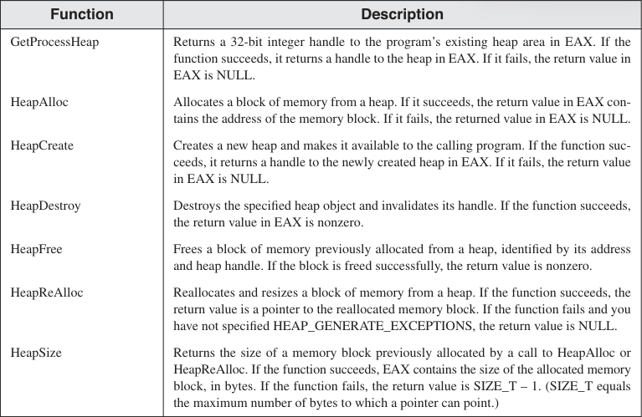

Here is a summary of the heap functions you provided:

GetProcessHeap() returns a handle to the current process's default heap.

HeapCreate() creates a new private heap for the current process.

HeapDestroy() destroys an existing private heap.

HeapAlloc() allocates a block of memory from a heap.

HeapFree() frees a block of memory previously allocated from a heap.

**When to use which function:**

Use GetProcessHeap() if you are content to use the default heap owned by the current program.

Use HeapCreate() to create a new private heap if you need more control over memory management.

Use HeapDestroy() to destroy a private heap when you are finished using it. Use HeapAlloc() to allocate memory from a heap.

Use HeapFree() to free memory that was allocated from a heap.

Here is an example of how to use the HeapAlloc() and HeapFree() functions to allocate and free a block of memory from a heap:

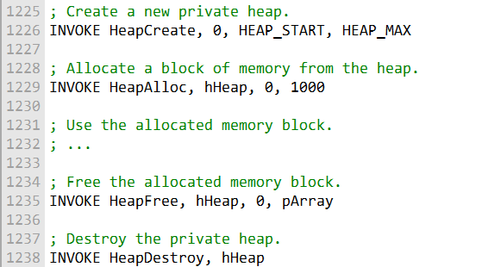

It is important to note that dynamic memory allocation should be used carefully to avoid memory leaks. A memory leak occurs when a program allocates memory but does not free it when it is finished using it. Memory leaks can lead to performance problems and eventually cause the program to crash.

Here's the complete program:

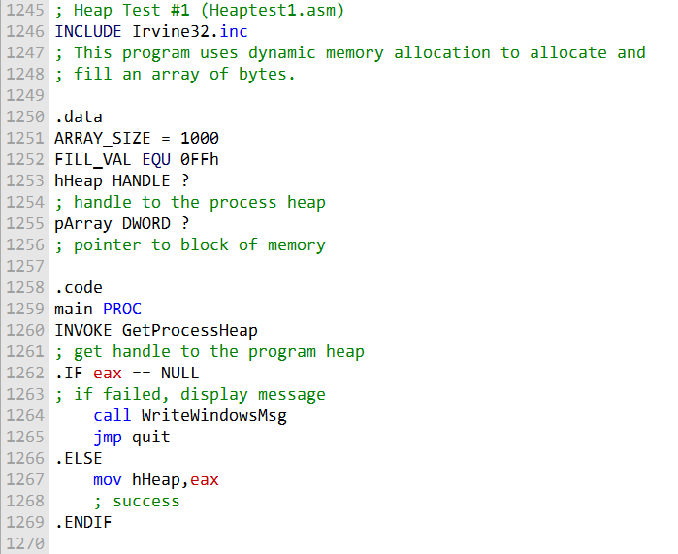

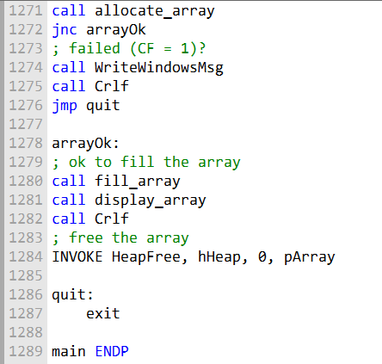

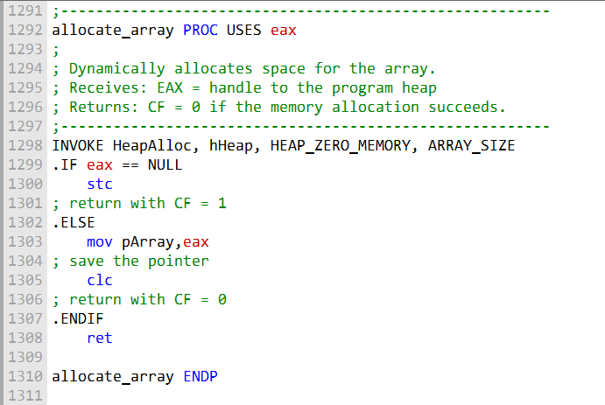

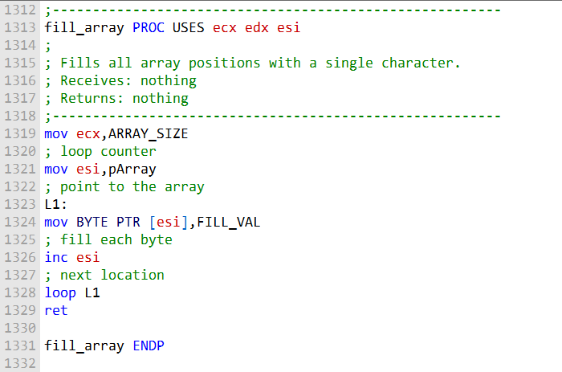

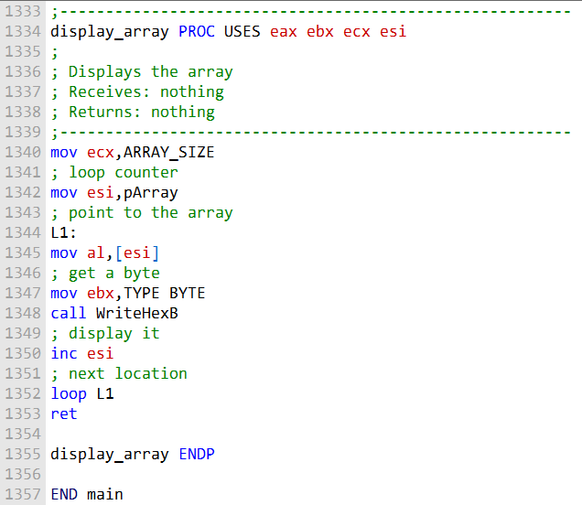

The HeapTest1.asm program is an assembly language example that showcases dynamic memory allocation and manipulation in the Windows environment.

The code demonstrates how to allocate memory from the heap, fill that memory with specific values, and display the allocated memory's contents.

The program starts with the .data section, where constants and variables are defined. It specifies the size of the array to be allocated, which is set to 1000 bytes, and the value used to fill the array, which is 0FFh.

The .code section begins with the main procedure. In this procedure, the program performs the following tasks:

It calls the GetProcessHeap function to obtain a handle to the default heap owned by the current process.

This is where memory allocations will be made. If obtaining the heap handle fails (resulting in a NULL handle), the program calls the WriteWindowsMsg function to display an error message and then exits.

If the GetProcessHeap call is successful, the obtained heap handle is stored in the hHeap variable for later use.

The program then proceeds to allocate memory for an array by calling the allocate_array procedure.

If memory allocation fails (indicated by the Carry Flag being set), it calls the WriteWindowsMsg function to display an error message and exits.

If allocation is successful, the pointer to the allocated memory is saved in the pArray variable.

After successful allocation, the program calls the fill_array procedure, which fills the allocated memory with a specified value (0FFh in this case).

Following the memory filling, the program calls the display_array procedure to display the contents of the allocated memory in hexadecimal format.

After displaying the memory contents, the program frees the allocated memory by invoking the HeapFree function.

The program then proceeds to the quit label, where it invokes the Exit system call to terminate the program.

In summary, HeapTest1.asm demonstrates the process of dynamic memory allocation in assembly language within the Windows environment.

It allocates memory from the default process heap, fills that memory with specific values, displays the memory's contents, and finally releases the allocated memory.

The program uses the GetProcessHeap function to obtain the default heap handle and the HeapAlloc and HeapFree functions for memory allocation and deallocation, respectively.

Let's move on to heaptest2.asm:

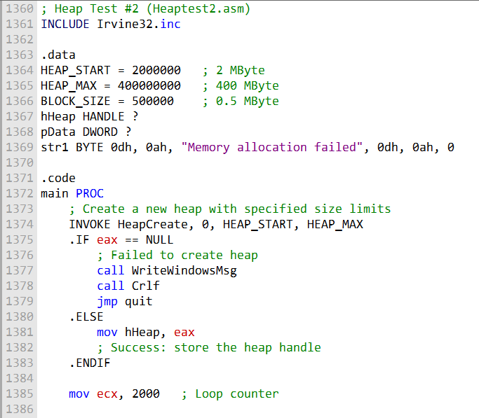

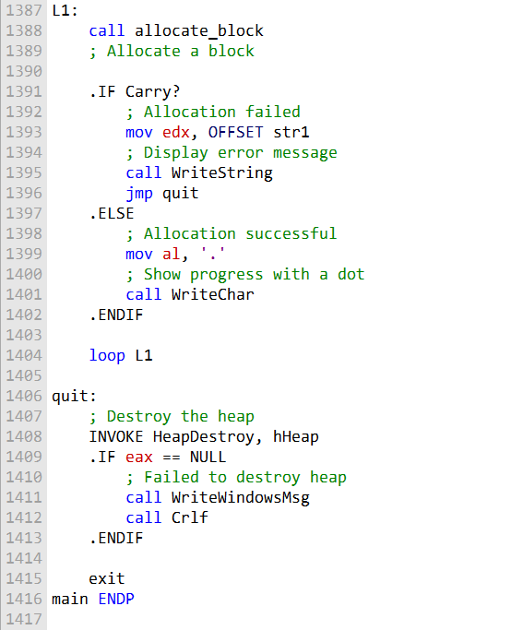

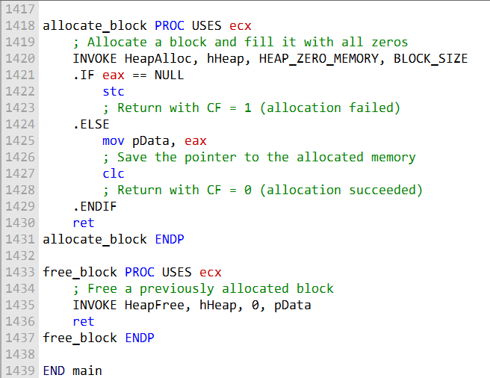

HeapTest2.asm is an assembly program that demonstrates dynamic memory allocation and usage of custom heap management.

It aims to allocate large blocks of memory repeatedly until the specified heap size limit is reached. The code is divided into sections for clarity.

The data section, defined using the .data directive, starts by declaring constants and variables.

**HEAP_START** is set to 2 megabytes (2MB), representing the initial heap size.

**HEAP_MAX** is set to 400 megabytes (400MB), indicating the maximum heap size.

BLOCK_SIZE is set to 0.5 megabytes (0.5MB), representing the size of memory blocks to be allocated.

The program uses hHeap to store the handle to the custom heap and pData to hold the pointer to the allocated memory. str1 is a string that will be used to display an error message in case of allocation failure.

The .code section contains the main procedure, labeled main PROC. It begins by invoking the HeapCreate function to create a new heap with specified initial and maximum sizes.

If the creation of the heap fails (resulting in a NULL heap handle), the program calls the WriteWindowsMsg function to display an error message and then jumps to the quit label to exit.

In case of a successful heap creation, the handle to the custom heap is stored in the hHeap variable for later use.

A loop is initiated using ecx as a loop counter, set to 2000 iterations. The purpose of this loop is to repeatedly allocate memory blocks.

Within the loop, the program calls the allocate_block procedure. This procedure uses the HeapAlloc function to allocate memory from the custom heap.

If memory allocation fails (indicated by the Carry Flag being set), the program displays an error message using str1, calls WriteString to print the message, and jumps to the quit label to exit.

If memory allocation is successful, a dot ('.') is displayed on the screen as a progress indicator, indicating a successful memory allocation.

The program continues the loop until all 2000 iterations are completed, each time allocating a memory block.

After the loop finishes, the program reaches the quit label, where it invokes HeapDestroy to destroy the custom heap.

If HeapDestroy fails (returns NULL), an error message is displayed using WriteWindowsMsg, and the program exits using the exit system call.

In summary, HeapTest2.asm showcases dynamic memory allocation using custom heap management. It repeatedly allocates memory blocks until a specified heap size limit is reached.

The program uses functions like HeapCreate, HeapAlloc, and HeapDestroy to manage custom heaps and memory allocation.

Progress is indicated by displaying dots for successful allocations, and any errors are communicated using appropriate error messages.

The program demonstrates the flexibility of heap management in assembly language within the Windows environment.

x86 MEMORY MANAGEMENT

Logical addresses and linear addresses are two different ways of addressing memory in an x86 processor.

A **logical address** is a combination of a segment selector and a 32-bit offset. The segment selector is a 16-bit value that identifies a segment descriptor, which in turn contains information about a memory segment. The offset is a 32-bit value that identifies a location within the segment.

A **linear address** is a 32-bit value that uniquely identifies a location in memory. It is calculated by adding the segment base address to the offset.

The x86 processor uses a two-step process to translate logical addresses to linear addresses:

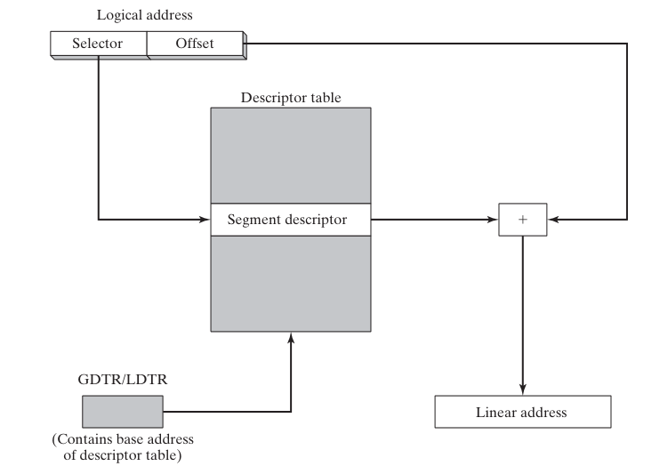

The **segment selector** is used to index the segment descriptor table (GDT or LDT) to obtain the segment descriptor.

The **segment base address** is added to the offset to produce the linear address. The following diagram shows the process of translating logical addresses to linear addresses:



Once the linear address has been calculated, the processor can use it to access memory directly.

***Example***

Suppose we have a program that has a variable at offset 200h in a segment with the segment selector value 0x1000. The segment descriptor table contains a segment descriptor for this segment with a base address of 0x100000.

To access this variable, the processor would first calculate the linear address:

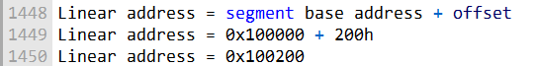

Once the linear address has been calculated, the processor can use it to access the variable at memory location 0x100200.

***Paging***

**Paging** is a memory management technique that allows the operating system to divide physical memory into pages.

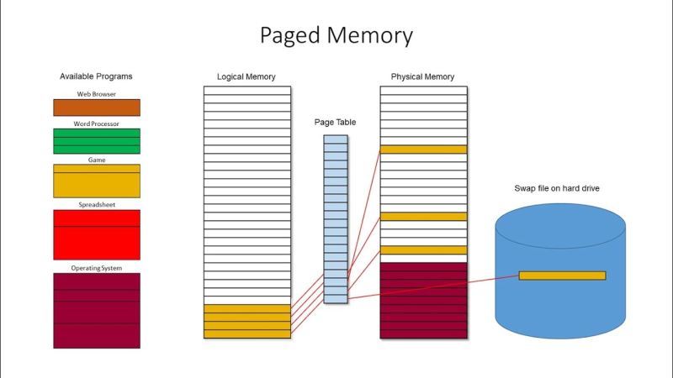

**Pages** are typically 4KB in size, but can also be 2MB or larger.

When a program needs to access memory, the operating system converts the program's linear address to a physical address using a page table.

The **page table** is a data structure that maps linear addresses to physical addresses.

The following diagram shows the process of translating linear addresses to physical addresses using a page table:



The page table index is the upper 20 bits of the linear address. The page offset is the lower 12 bits of the linear address.

The operating system can use paging to implement a number of features, such as virtual memory and memory protection.

***Conclusion***

Logical addresses and linear addresses are two different ways of addressing memory in an x86 processor. Logical addresses are used by programs, while linear addresses are used by the processor.

The processor translates logical addresses to linear addresses using segment descriptors. Linear addresses can then be translated to physical addresses using a page table.

***=================================***

***Descriptor tables***

***=================================***

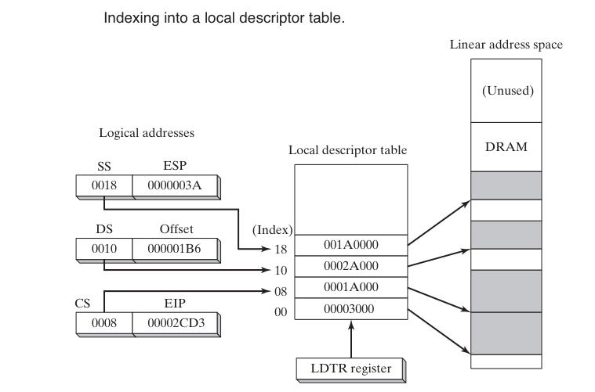

Descriptor tables are data structures that contain information about memory segments. A segment is a variable-sized area of memory that is used by a program to store code or data.

There are two types of descriptor tables:

**Global Descriptor Table (GDT):** The GDT contains segment descriptors for all of the segments that are used by the system.

**Local Descriptor Table (LDT):** Each task or process has its own LDT, which contains segment descriptors for the segments that are used by that task or process.

Segment descriptors contain information about a segment, such as its base address, size, and access rights. The processor uses this information to translate logical addresses to linear addresses.

A logical address is a combination of a segment selector and a 32-bit offset. The segment selector is a 16-bit value that identifies a segment descriptor in the GDT or LDT. The offset is a 32-bit value that identifies a location within the segment.

The processor calculates the linear address by adding the segment base address to the offset. The linear address is then used to access memory directly.

Suppose we have a program that has a variable at offset 200h in a segment with the segment selector value 0x1000.

The GDT contains a segment descriptor for this segment with a base address of 0x100000.

To access this variable, the processor would first calculate the linear address:

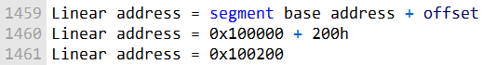

Once the linear address has been calculated, the processor can use it to access the variable at memory location 0x100200.

***Segment descriptor details***

In addition to the segment's base address, the segment descriptor contains the following information:

**Segment limit:** The segment limit specifies the maximum size of the segment. If a program tries to access a memory location outside of the segment limit, a processor fault is generated.



**Segment type:** The segment type specifies the type of data that is stored in the segment. For example, a code segment contains code, and a data segment contains data.

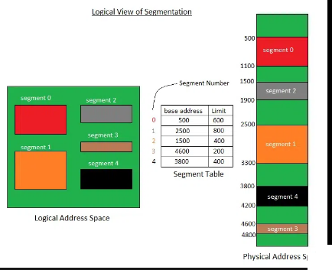

**Access rights:** The access rights specify which operations are allowed on the segment. For example, a read-only segment can only be read, and a write-only segment can only be written to. The processor uses this information to ensure that programs do not access memory in an unauthorized way.



***Segment descriptors in x86 processors contain a number of fields that control how the segment is used, including:***

**Base address:** The starting address of the segment in the linear address space.

**Privilege level:** The privilege level required to access the segment.

**Segment type:** The type of segment, such as code, data, or stack.

**Segment present flag:** Indicates whether the segment is present in memory.

**Granularity flag:** Determines whether the segment limit is interpreted in bytes or 4096-byte units.

**Segment limit:** The maximum size of the segment.

The **protection level field** is used to protect operating system data from access by application programs.

Each segment can be assigned a **privilege level** **between 0 and 3**, where 0 is the most privileged and 3 is the least privileged.

If a program with a **higher privilege level** tries to access a segment with a lower privilege level, a processor fault is generated.

This prevents application programs from **accidentally or maliciously** modifying operating system data.

[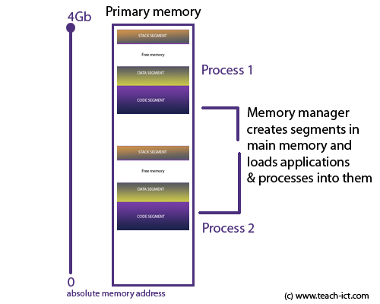](https://www.teach-ict.com/as_as_computing/ocr/H447/F453/3_3_1/memory%20management/miniweb/images/allmemory.jpg)

So,

The **segment type field** is used to specify the type of data that is stored in the segment and the type of access that is allowed. For example, a code segment can only be executed, and a data segment can only be read or written to.

The **segment present flag** is used to indicate whether the segment is currently present in memory. If the flag is set, the segment is present in memory and can be accessed. If the flag is not set, the segment is not present in memory and cannot be accessed.

The **granularity flag** is used to determine how the segment limit field is interpreted. If the flag is set, the segment limit is interpreted in 4096-byte units. If the flag is not set, the segment limit is interpreted in bytes.

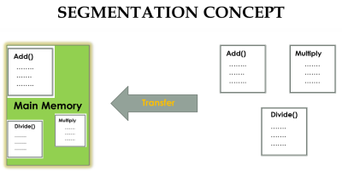

The **segment limit field** specifies the maximum size of the segment. If a program tries to access a memory location outside of the segment limit, a processor fault is generated.

**Segment descriptors** are an important part of memory management in x86 processors. They allow the processor to translate logical addresses to linear addresses and to ensure that programs do not access memory in an unauthorized way.

[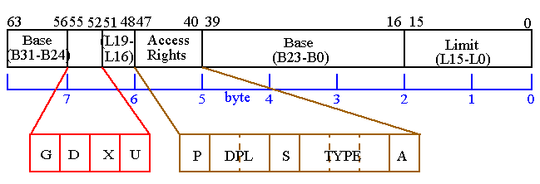](https://ece-research.unm.edu/jimp/310/slides/micro_arch2-2.gif)

Described segment descriptor:

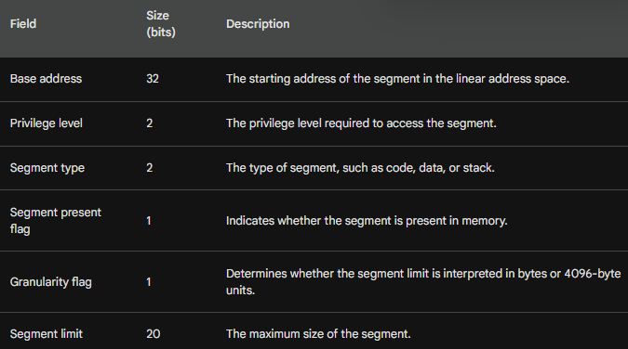

The segment descriptor image also shows the following:

The segment descriptor table (GDT) is located at address 0x00000000. The segment selector is a 16-bit value that identifies a segment descriptor in the GDT.

The linear address is a 32-bit value that identifies a memory location in the linear address space.

The processor uses the segment selector to index the GDT to obtain the segment descriptor.

The segment descriptor is then used to calculate the linear address of the memory location.

***==========================***

***Page translation:***

***===========================***

Page translation is the process of converting a linear address to a physical address in an x86 processor when paging is enabled.

A linear address is a 32-bit value that uniquely identifies a location in memory. A physical address is also a 32-bit value, but it identifies a location in physical memory.

Paging allows the operating system to divide physical memory into pages, which are typically 4KB in size. The operating system then uses a page table to map virtual addresses to physical addresses.

The page table is a data structure that contains one entry for each page in the virtual address space.

Each entry contains the physical address of the page and its access rights.

When the processor needs to access a memory location, it first translates the linear address to a physical address using the page table.

The processor does this by looking up the page table entry for the linear address. The page table entry contains the physical address of the page and its access rights.

If the page table entry is valid, the processor uses the physical address to access the memory location.

If the page table entry is not valid, the processor generates a page fault.

***Steps in page translation***

Let's describe the page table image first:

The linear address references a location in the linear address space. The 10-bit directory field in the linear address is an index to a page-directory entry. The page-directory entry contains the base address of a page table.

The 10-bit table field in the linear address is an index into the page table identified by the page-directory entry. The page-table entry at that position contains the base location of a page in physical memory.

The 12-bit offset field in the linear address is added to the base address of the page, generating the exact physical address of the operand.

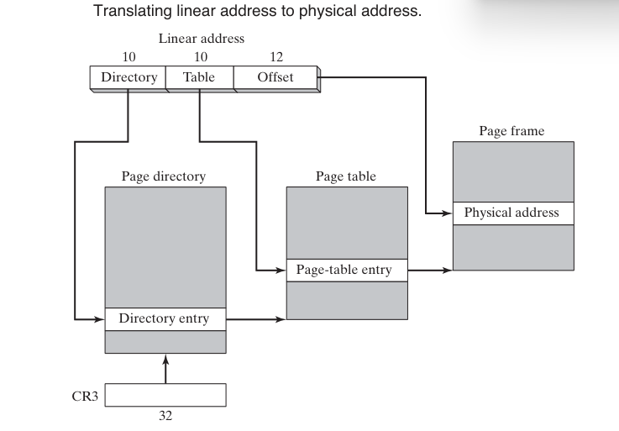

The following steps are carried out by the processor when translating a linear address to a physical address:

The processor splits the linear address into three fields:

**Directory field:** The directory field is the upper 10 bits of the linear address.

**Table field:** The table field is the middle 10 bits of the linear address. Offset field: The offset field is the lower 12 bits of the linear address.

The processor uses the directory field to index the page directory. The page directory is a table of 1024 4-byte entries.

Each entry in the page directory points to a page table. The processor uses the table field to index the page table pointed to by the directory entry.

The page table is also a table of 1024 4-byte entries. Each entry in the page table points to a physical page frame.

The processor adds the offset field to the physical address of the page frame pointed to by the page table entry. This results in the physical address of the memory location. Example:

Suppose we have a linear address of 0x12345678. The **directory field** would be 0x1234, the **table field** would be 0x5678, and the **offset field** would be 0x123456.

The processor would first use the directory field to index the page directory. The page directory entry at index 0x1234 would contain the address of the page table.

The processor would then use the table field to index the page table. The page table entry at index 0x5678 would contain the physical address of the page frame.

Finally, the processor would add the offset field to the physical address of the page frame. This results in the physical address of the memory location, which is 0x12345678.

***Conclusion***

The operating system has the option of using a single page directory for all running programs and tasks, or one page directory per task, or a combination of the two.

Page translation is an important part of memory management in x86 processors. It allows the operating system to divide physical memory into pages and to map virtual addresses to physical addresses.

This allows the operating system to implement virtual memory and to protect memory from unauthorized access.

***===============================***

***Windows Virtual Machine Manager***

***===============================***

**Windows Virtual Machine Manager (VMM)** is the 32-bit protected mode operating system at the core of Windows. It is responsible for creating, running, monitoring, and terminating virtual machines. It also manages memory, processes, interrupts, and exceptions.

[](https://www.webopedia.com/wp-content/uploads/2020/10/system-center-virtual-machine-manager_5f8576febaca6-2.png)

VMM uses a single 32-bit flat model address space at privilege level 0. This means that all of the virtual machines, the VMM itself, and any virtual devices all share the same address space.

The VMM creates two global descriptor table (GDT) entries for each virtual machine, one for code and one for data. These segments are fixed at linear address 0.

VMM provides multithreaded, preemptive multitasking. This means that it can run multiple applications simultaneously by sharing CPU time between the virtual machines in which the applications run.

**How VMM handles memory management**

VMM uses a technique called paging to manage memory. Paging divides physical memory into pages, which are typically 4KB in size. VMM then uses a page table to map virtual addresses to physical addresses.

Each virtual machine has its own page table. The page table tells the processor which physical page contains a particular virtual address.

When a virtual machine tries to access a memory location, the processor first looks up the page table entry for that virtual address.

If the page table entry is valid, the processor uses it to access the physical memory location. If the page table entry is not valid, the processor generates a page fault.

Page faults are handled by the VMM. When a page fault occurs, the VMM checks to see if the virtual address is valid. If it is, the VMM loads the corresponding physical page into memory and updates the page table entry.

If the virtual address is not valid, the VMM generates an exception.

**Benefits of using VMM**

VMM offers a number of benefits, including:

**Isolation:** VMM isolates virtual machines from each other, so that a failure in one virtual machine does not affect other virtual machines.



**Security:** VMM can be used to implement security features such as access control and encryption.



**Performance:** VMM can improve the performance of applications by running them in separate virtual machines.



**Flexibility:** VMM can be used to create and manage different types of virtual machines, such as servers, desktops, and test environments.



Windows Virtual Machine Manager is a powerful tool that can be used to create, run, and manage virtual machines. VMM offers a number of benefits, including isolation, security, performance, and flexibility.